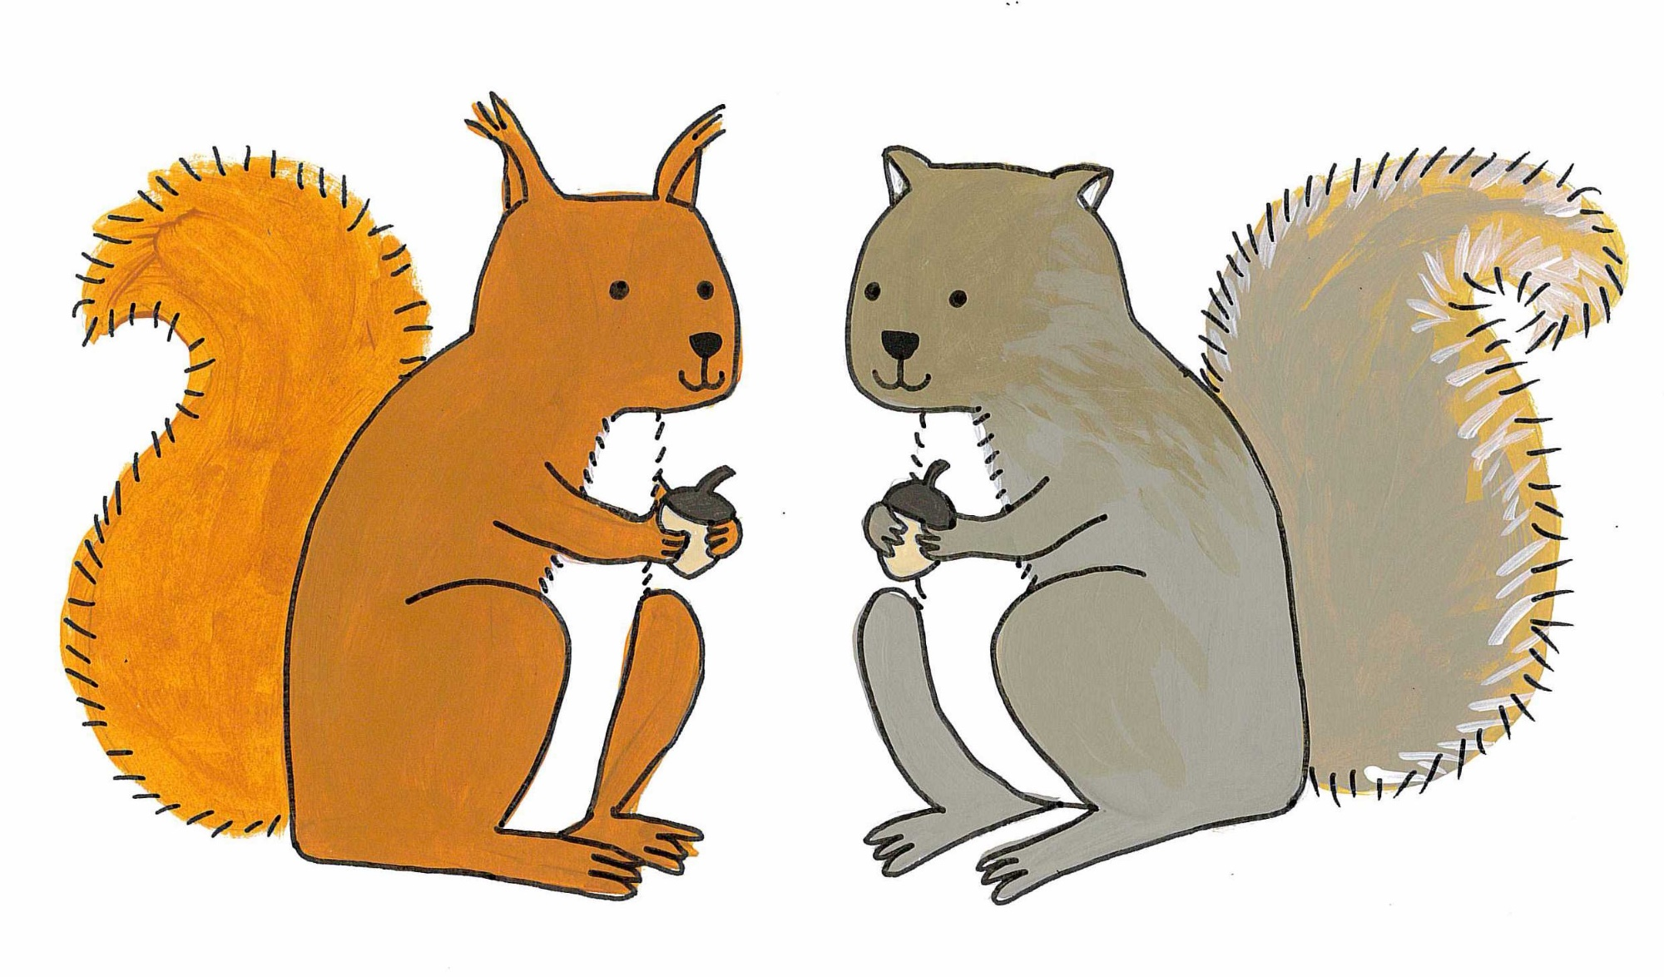
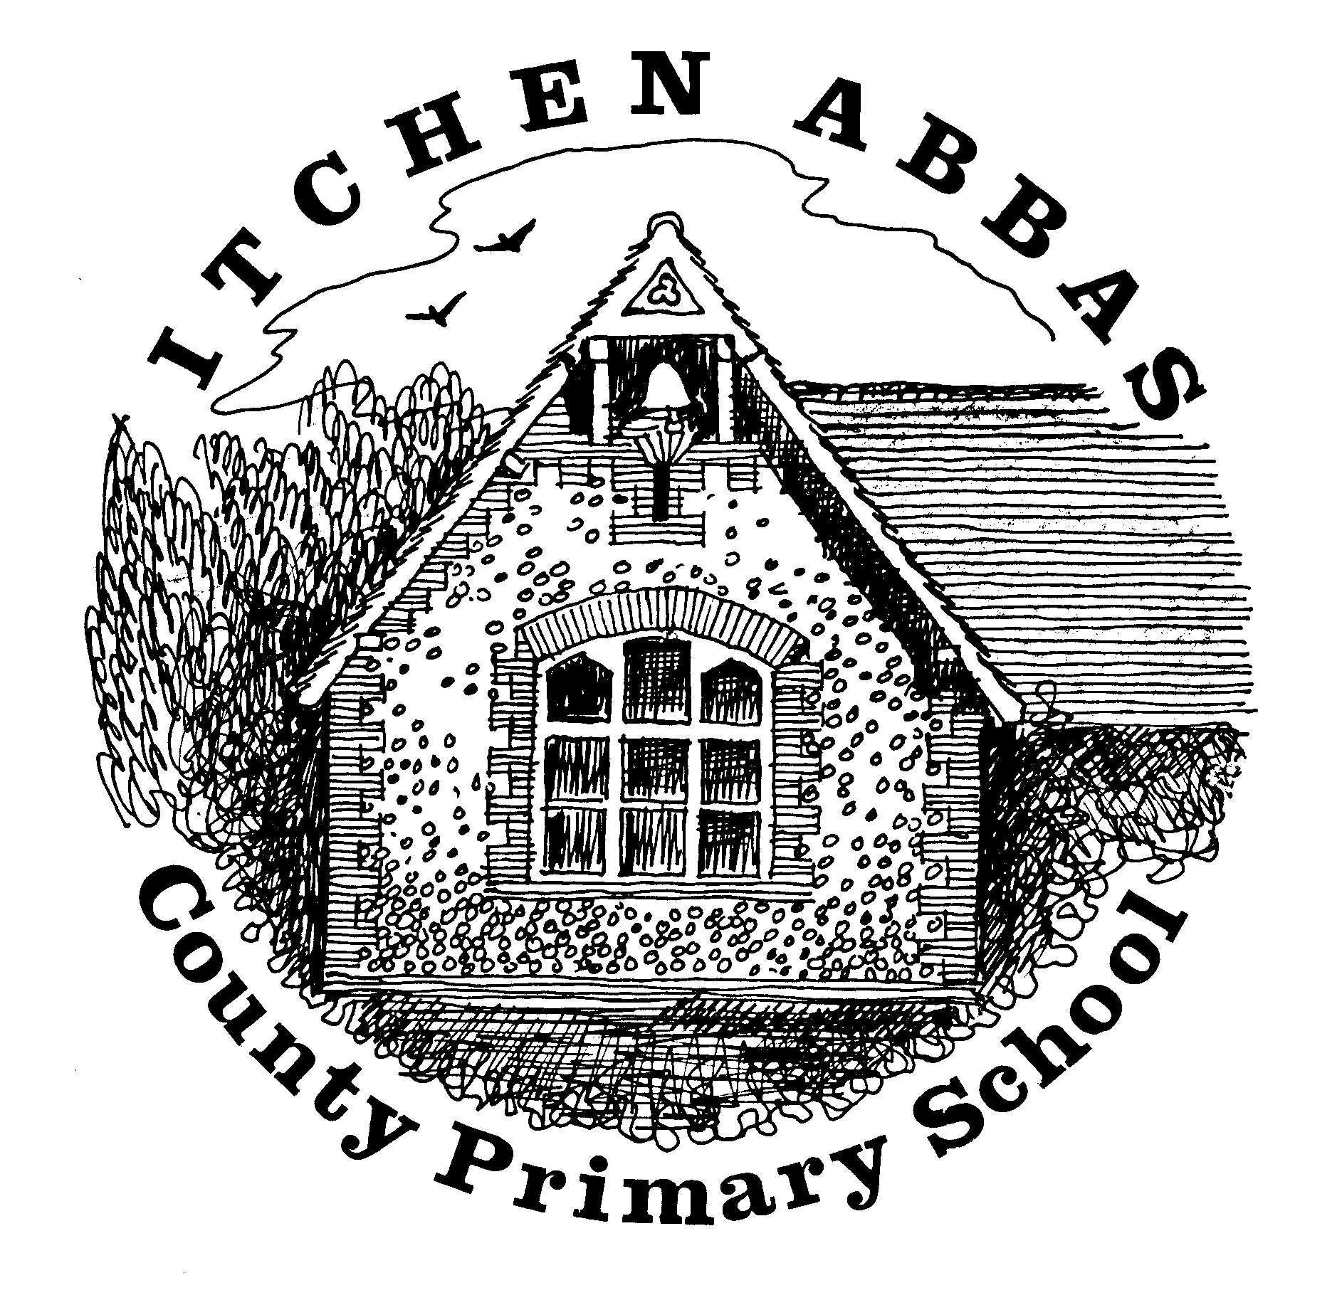
Itchen Abbas Primary School

Squirrel’s overview of Learning for Autumn 2 2020/21

Overview of Our Topic – Our School, Our City
This half term we are continuing to study the History of Itchen Abbas Primary School. The children will compare photographs of the school to see how it has developed over time. We will then move on to learn about where the city of Winchester is in the UK by identifying the 4 countries and their capital cities.
Vocabulary. These are words that we will be using in our learning. To help the children learn these new words, please have some fun using the words at home in different contexts.

school village town city country map capital
compare similarities differences geographical historical

English  This half term, we will be exploring fairy tales and traditional stories. This will be hooked off with a drama workshop. In phonics, the year R children have now learnt all phase 2 sounds and will be embedding the sounds they know, and the year one children will be continuing to learn phase 5. | Maths  As well as number, Maths encompasses shape, space and measure. This half term, the children will be learning about different measures through time and money. We will also explore some 2D and 3D shapes. The year ones will also enhance their multiplication, division and place value skills by counting in 2’s, 5’s and 10’s.
Music  I am extremely pleased to announce that we are still going to perform a Nativity play this year. Whilst we work out the technicalities of putting on a performance, the children will be spending lots of time learning the songs. Prepare yourselves for some ear worms. | Science  This half term, Mrs Cook will be teaching the children about animals. The children will identify the different categories of animals, explore diets and habitats and compare animals to humans.
RE  The Squirrels will be learning about the birth of Jesus through the means of the Nativity performance. They will contextualise their understanding of birth by exploring their families/ friend’s experiences of new babies. | Art & DT  In Art, the children will learn how to collage. They will have the opportunity to create lots of different pieces which will allow the children to practise and refine their skills. The Squirrels will also research the work of Ben Lewis Giles.
Computing  Mrs Cook will be developing the children’s digital literacy skills this half term. They will learn the basics of how to turn on computers, use a mouse, save documents and navigate a computer. | PE  Mr Robbins will continue to develop the children’s fundamental P.E skills whilst also learning balancing skills in gymnastics.
PSHE
This half term, the children will continue to develop their self-compassion skills by identifying and understanding a range of emotions. All of the children have been settling into school very well and each child is beginning to develop new friendships. We will continue to help the children develop these friendships and their social skills.

