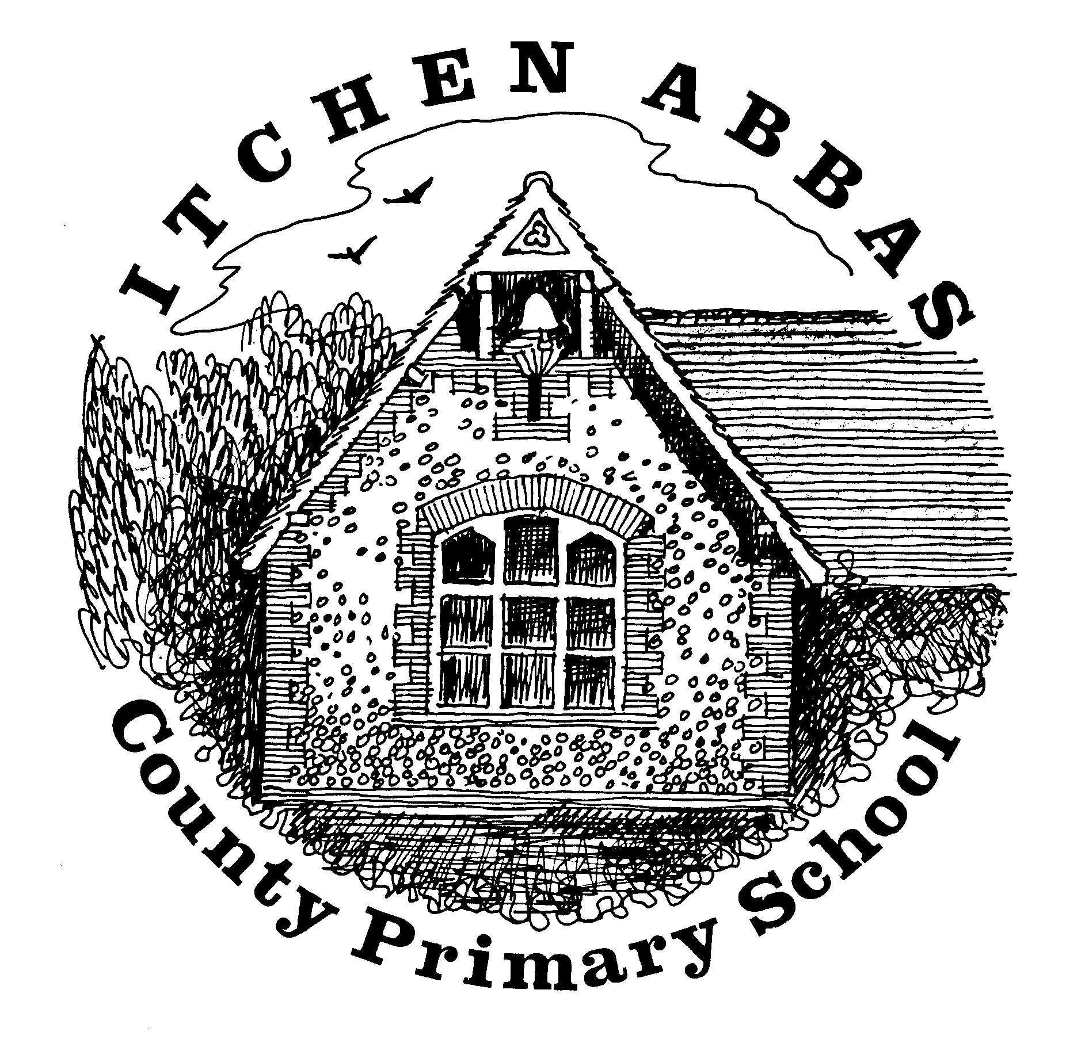
Itchen Abbas Primary School

Class overview of Learning for Summer Term 2019

Around the World

Overview of Our Topic
Our new topic ‘Around the World’ will explore the wonderful places on Earth. The children will learn to identify different countries, continents and oceans and they will be comparing England to other countries around the world, with a particular focus on Pakistan. Our topic will be filled with exciting experiences and special visitors who will be able to educate us on what life is like in Pakistan.
Vocabulary. These are words that we will be using in our learning. To help the children learn these new words, please have some fun using the words at home in different contexts.

country island Earth continents similarities

Asia Europe ocean culture differences
English  For English this half term, we will be focusing on traditional tales and comparing English stories to Pakistani stories. The children will have the chance to share their favourite stories and listen to some new ones. We will then adapt these traditional tales to create alternative endings. |  | Science  In science, we will be thinking about healthy eating by exploring fruits from around the world. The children will learn the importance of a healthy, balanced diet and the importance of exercise.
Maths  This half term, the children will be linking the ideas and concepts of shape and patterns whilst exploring art work and architecture in Pakistan. |  | Music  The Squirrels will be listening to traditional music from around the world and learning about different instruments played in those countries. Miss Duncan will also be teaching the children some Bollywood dancing.
History  Whilst learning about the different continents of the world, we will briefly explore how these continents came to be. |  | Art & DT  During art lessons, the children will be exploring South Asian art work. There will be a particular focus on colour mixing and the children will explore different techniques used in these countries to create their own piece.
Computing  Squirrels will be continuing to learn about how to use technology and the internet safely. Alongside this, we will also practice our typing skills. |  | PE  Throughout the half term, Mr Robbins will be teaching the children a variety of athletic sports and gymnastic skills.
PSHE  In PSHE the Squirrels will be learning about responsibilities and expectations in order to prepare them for the transition of year groups. The children will be given different classroom responsibilities that they must help each other to fulfil. | RE  Mrs Rymill will be teaching the children about special places. The children will think about what places are special to them. They will then explore special religious places for Christians and other religions around the world to compare them. |  | MFL  N/A

