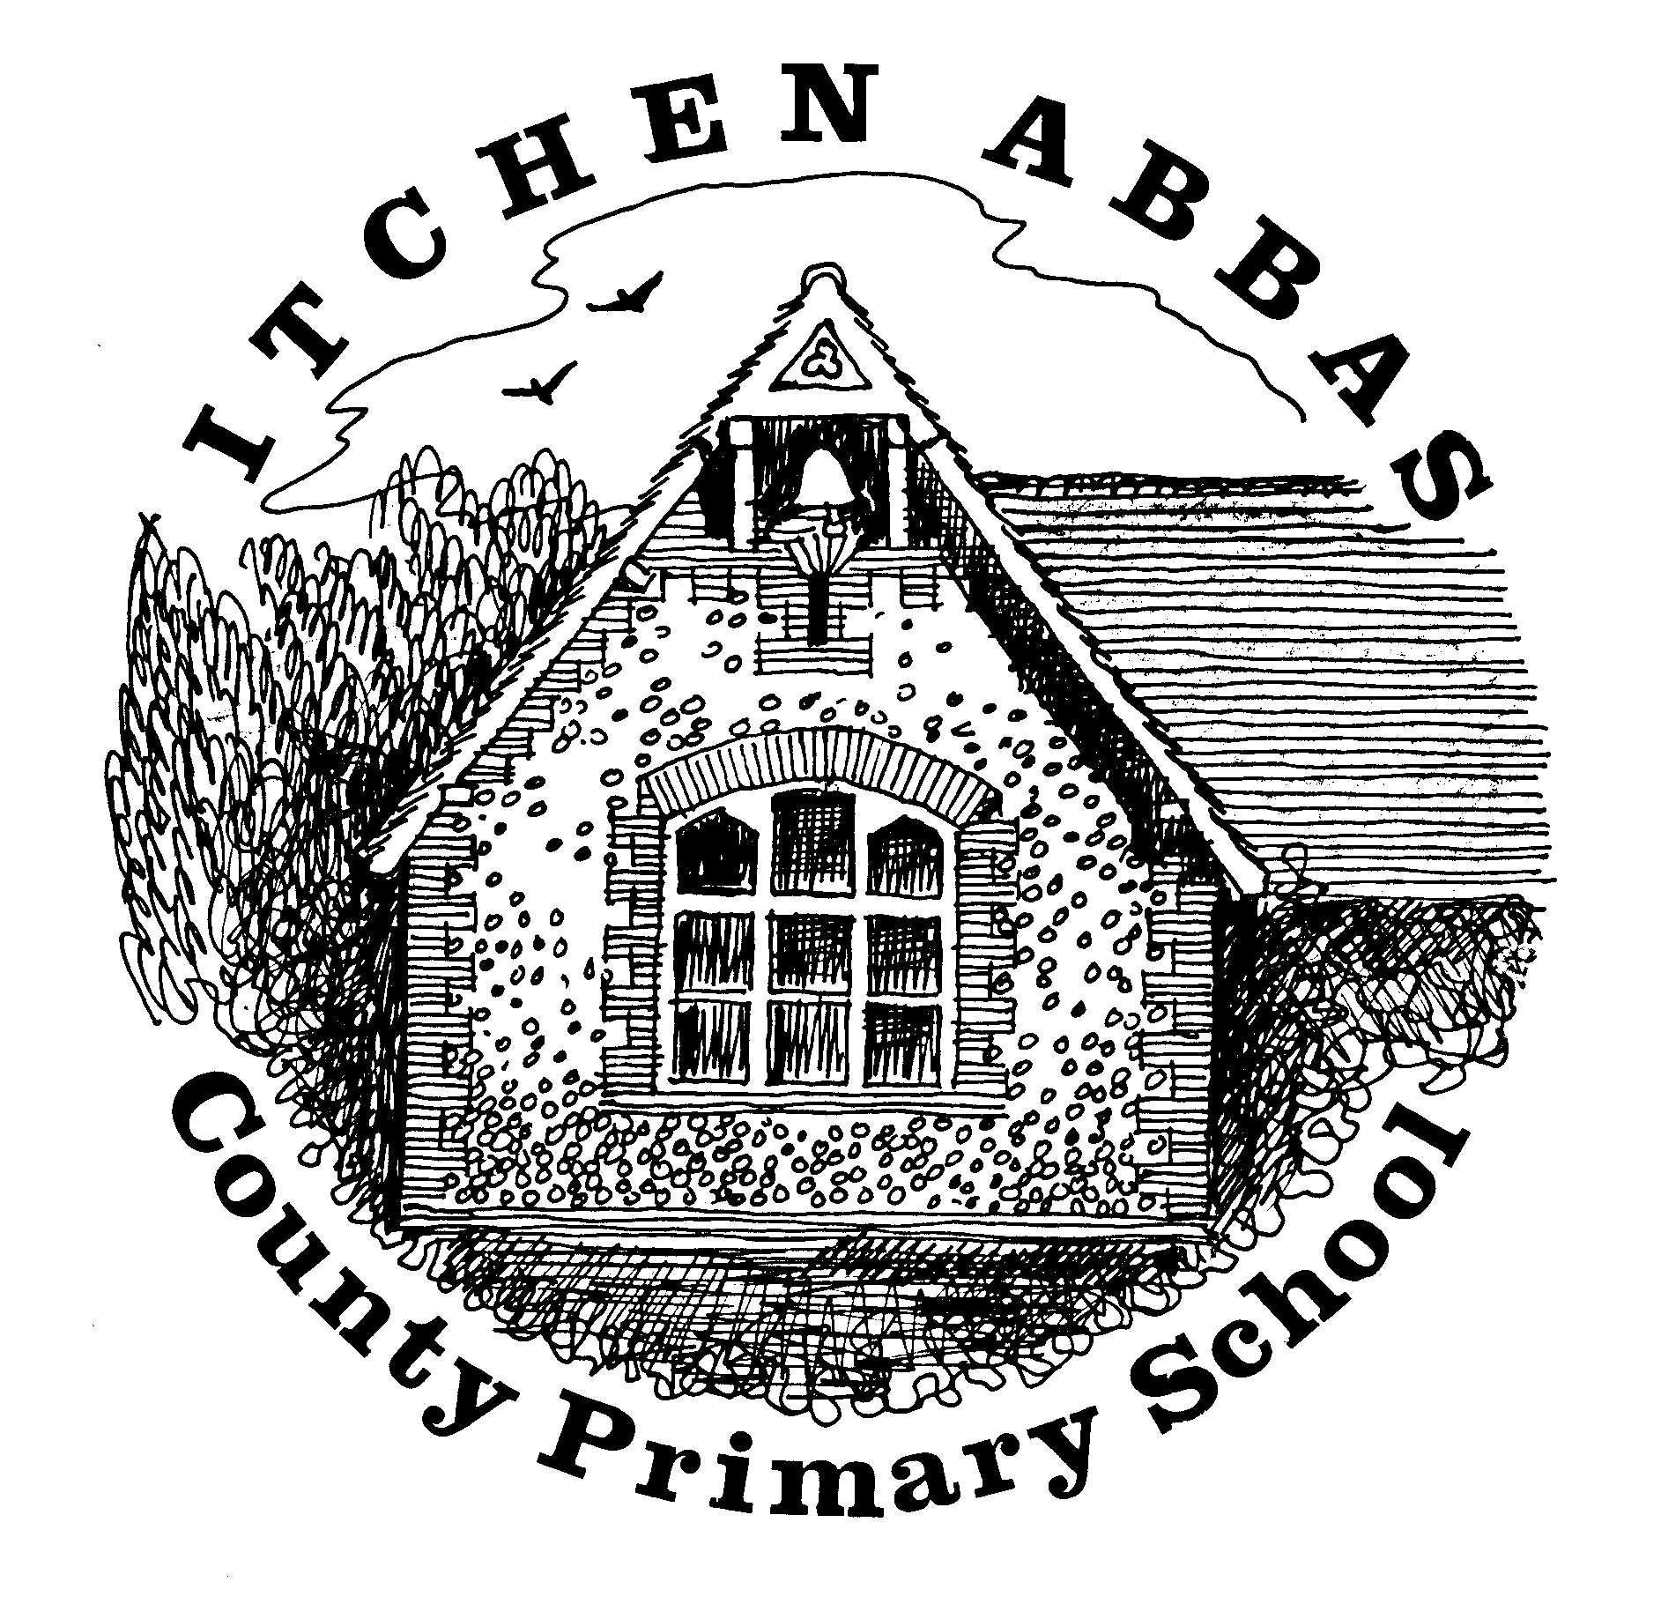
Itchen Abbas Primary School
Homework for Autumn 2 2019/20

Year 1

All children are expected to complete the green squares, this is your core homework. Yellow squares are optional for those of you who want an extra challenge. White squares are your home learning. Choose at least two of these to complete. Date the squares as you complete them.
All homework is to be brought into school by Friday 13th December 2019.

Reading Task | Writing Task | Maths Fluency Task | Maths Problem Solving Task
Find and read an interesting newspaper or magazine article about animals in the UK.  Due: 15th November 2019 | Practice forming all letters and numbers correctly (including capital letters).  Due: 22nd November 2019 | Counting and addition focus:  Practise number bonds to 10.  Practise counting forwards in 5’s.  Due: 29th November 2019 | Find a variety of objects in your home. Put them in order from biggest to smallest, heaviest to lightest and longest to shortest.  Due: 6th December 2019
Spelling |  | Reading
Weekly practice from your spelling journey |  | Record your home reading in your reading record
Topic | Research | Food Tech |  | Home Learning
Search through old pictures of family celebrations you have taken part in and make a collage. This can include birthdays, weddings, religious ceremonies etc. | Choose a celebration from around the world and research it. This can be one that you celebrate or a celebration you’ve never heard of before. | Make some festive bakes. |  | Your choice: choose an activity to help you find out more about our topic
Music | Going places | Art/DT |  | Computing
Practise the Christmas play songs.  Learn some traditional Christmas carols. | Visit the Winchester Christmas market to explore a range of Christmas traditions. | Use a variety of fruits and vegetables to cut out different shapes and print pictures. |  | Practise your typing skills by writing a list of tricky words.
Reading Challenge | Science Challenge | Maths Reasoning Challenge |  | Writing Challenge
Create a list of questions you would like to ask your favourite book character. | Design and make a habitat for a nocturnal animal. | Eggs in a basket investigation. |  | Write your own Nativity/ Christmas play.

