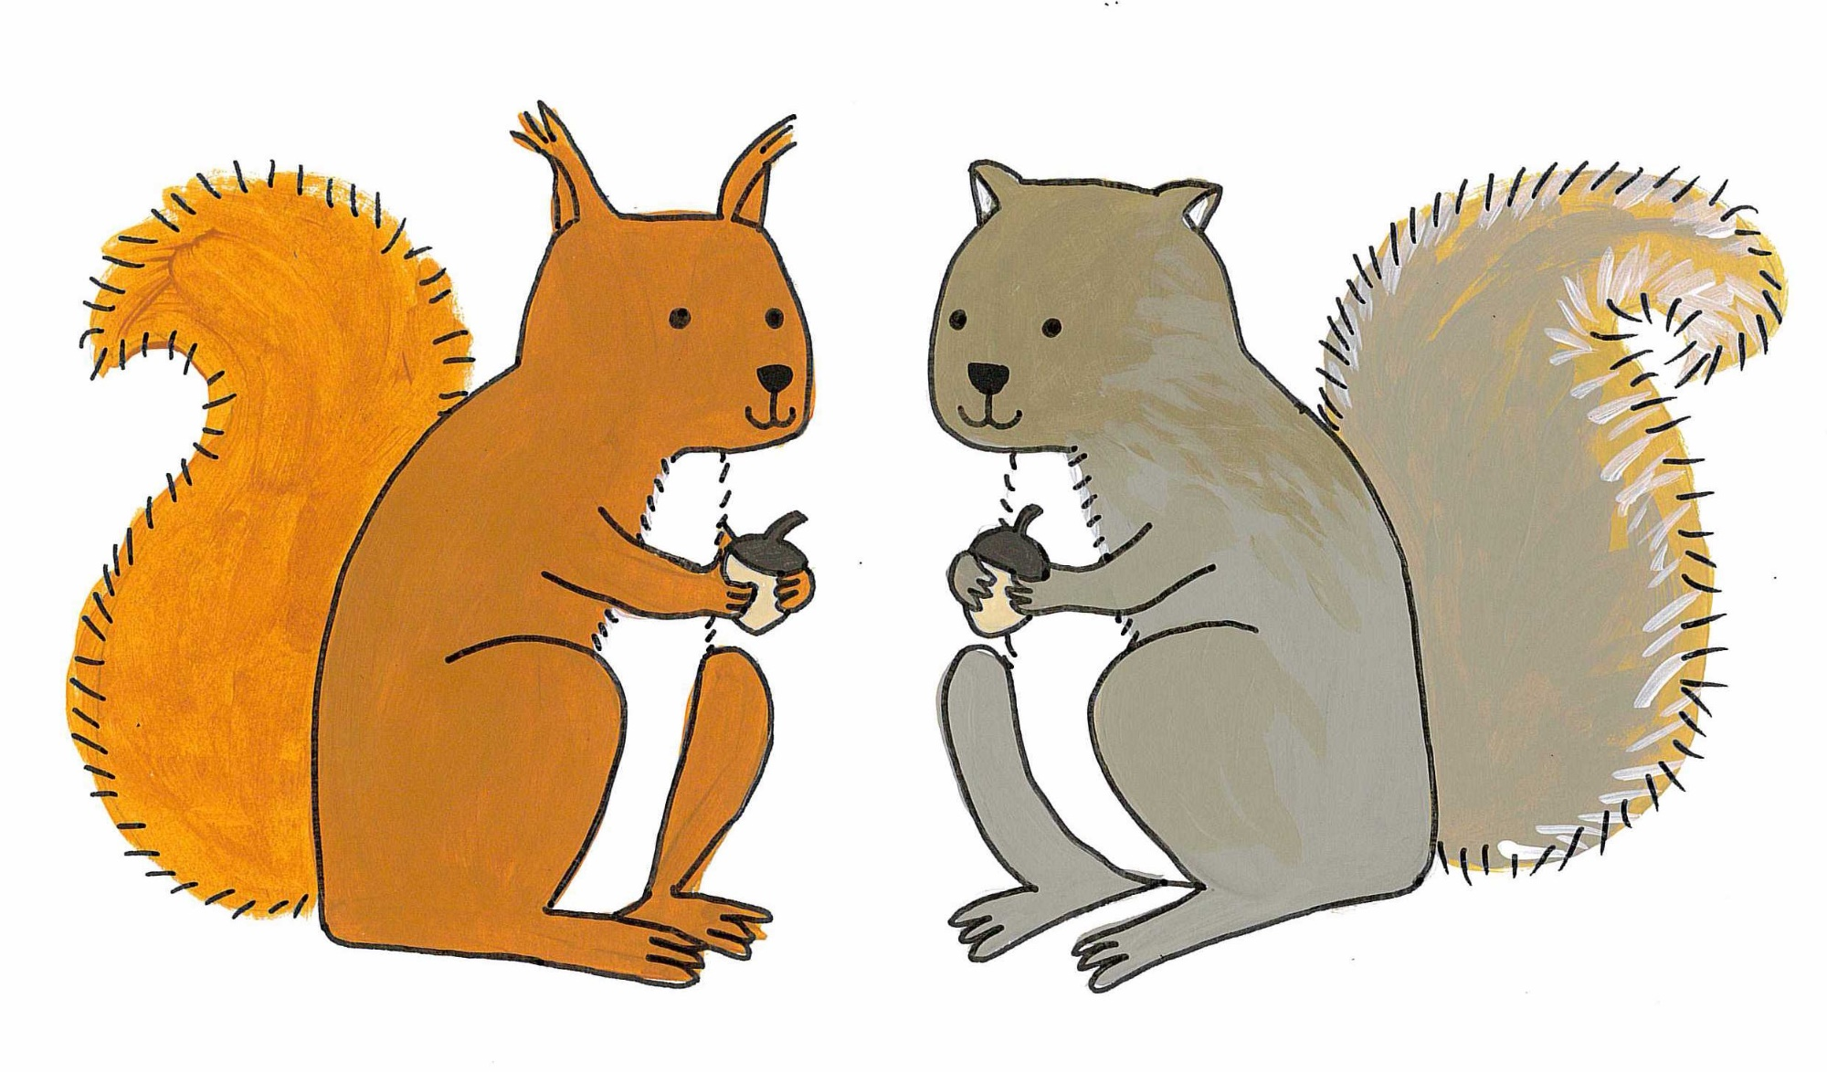
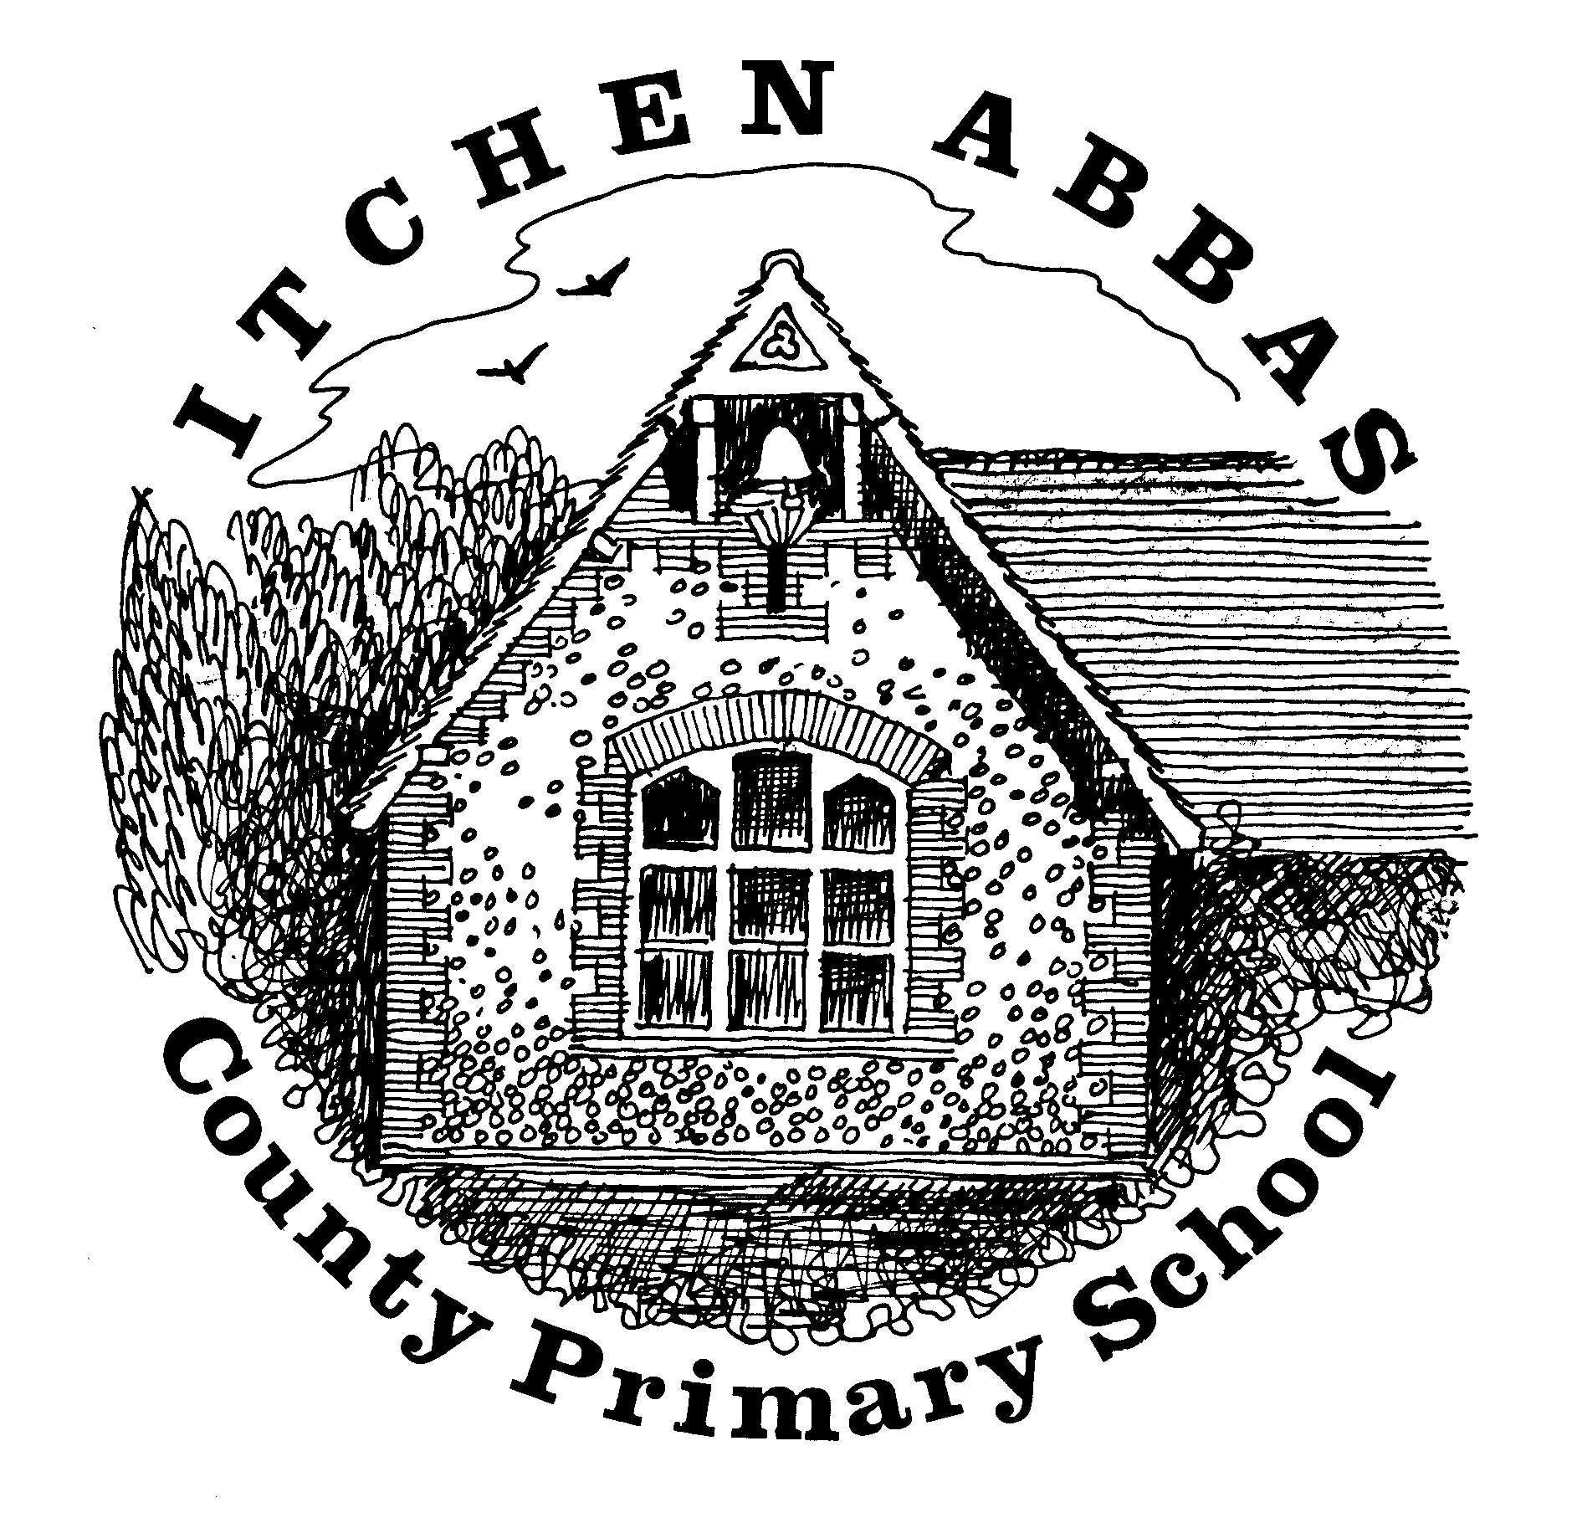
Itchen Abbas Primary School

Squirrel’s overview of Learning for Autumn 2 2019/20

Overview of Our Topic – Celebrations
For this topic, the Squirrels will be exploring a variety of religious and non-religious celebrations that take place across the UK. They will explore bonfire night, weddings, patron saints days, New Years, Valentines day and Christmas.
Vocabulary. These are words that we will be using in our learning. To help the children learn these new words, please have some fun using the words at home in different contexts.

celebration festival ceremony beliefs traditional modern religious

countries United Kingdom nocturnal diurnal
English  Our English this half term will link closely to our Science learning. The children will look closely at a picture book about nocturnal animals and create their own stories from the pictures. They will also study non-fiction texts about animals to help them compose their own piece of factual writing. | Science  Mrs Primmer will be teaching the Squirrels about different types of animals including mammals, amphibians, reptiles, birds and fish. From this, children will learn about nocturnal and diurnal animals in the UK. They will research facts and information about an animal of their choosing.
Maths  This half term, the children will be concentrating on the 4 mathematical operations: addition, subtraction, multiplication and division. They will also begin to explore 2D shapes in geometry and money in measurement. | Music  The Squirrels will be learning songs for their Christmas play. They will also be listening to a variety of songs played and/ or sung during different celebrations.
Geography  Our topic will start by exploring maps and pictures of the UK. The children will identify the four countries and locate where Itchen Abbas is within England. As the Squirrels learn about each celebration, they will locate where it is celebrated in the UK. | Art & DT  In Art, the Squirrels will be creating Christmas decorations using printing skills. They will also explore a variety of printing artists.  To finish off the term, the children will be doing more cooking and making mince pies to celebrate Christmas.
Computing  Mrs Primmer will be teaching the children some typing skills. Typing helps to develop phonics and letter recognition. Learning to type also enables children to use technology more fluently. | PE  Mr Robbins will be teaching the children about team games and continuing to develop their fundamental P.E skills.
PSHE  In Squirrels, we will be exploring how people celebrate and compare the similarities and differences between these celebrations. The children will learn that everyone is different and we each have our own beliefs and traditions that should be respected. | RE  This half term, there will be a focus on learning about the birth of Jesus to help the children understand why Christians celebrate Christmas.

