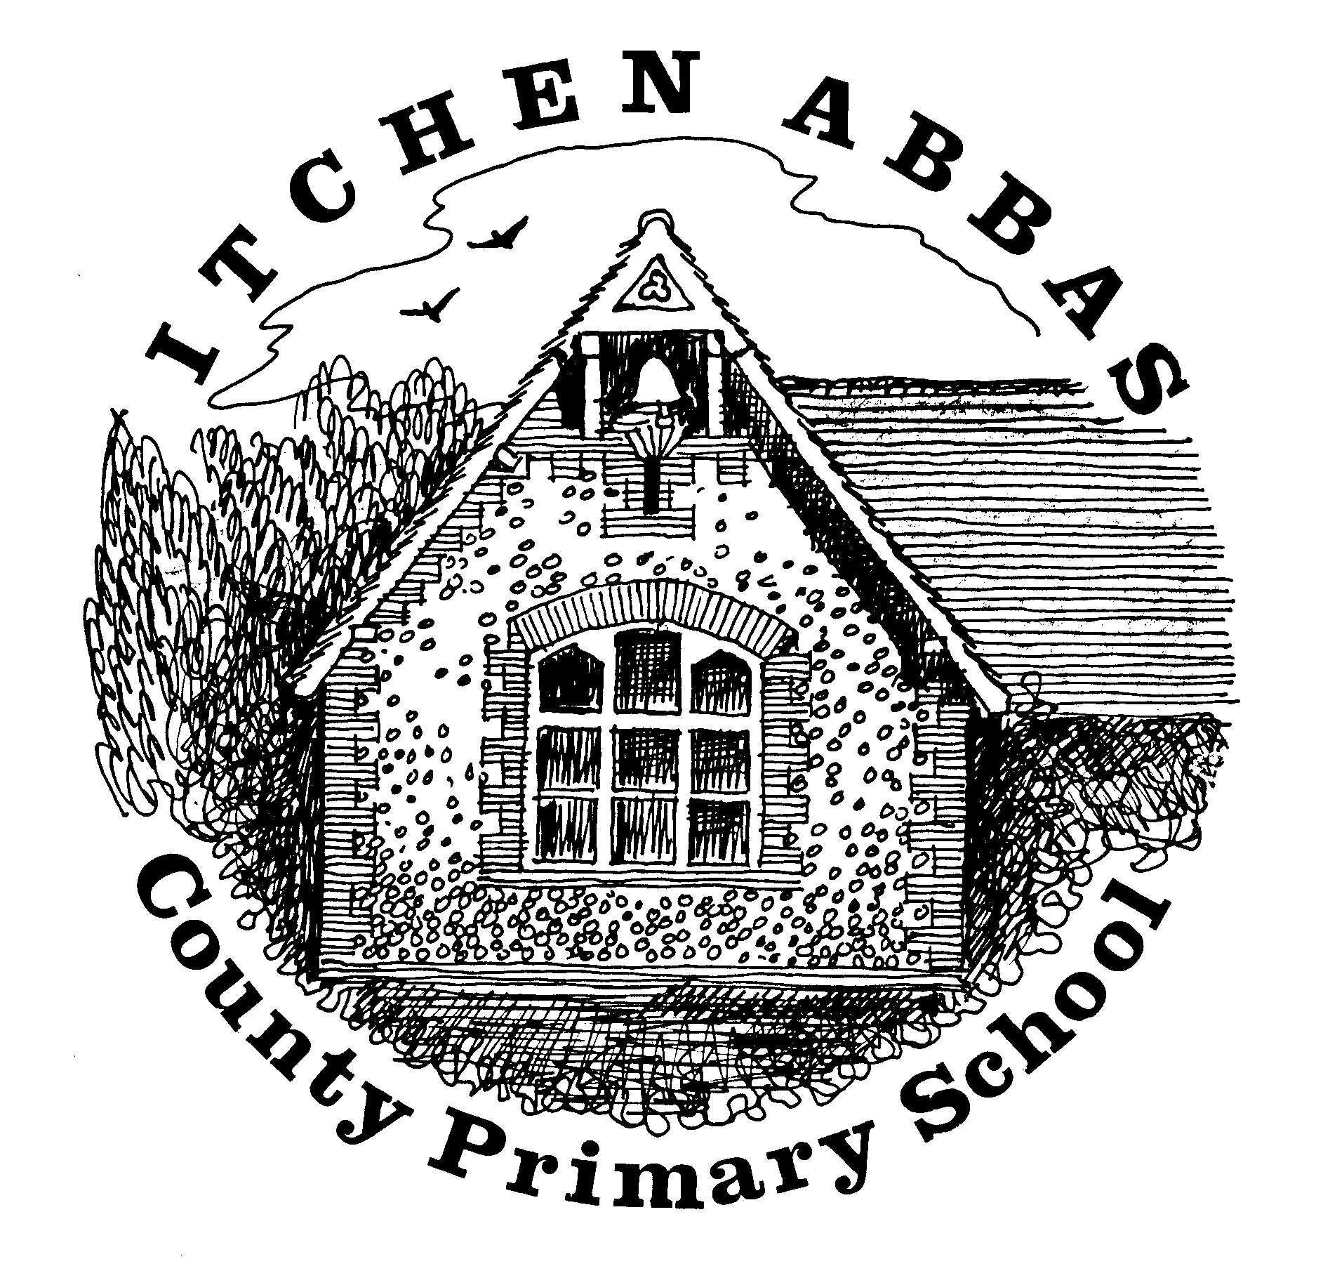
Itchen Abbas Primary School
Homework for Spring 2 2020

Year 3

All children are expected to complete the green squares, this is your core homework. Yellow squares are optional for those of you who want an extra challenge. White squares are your home learning. Choose at least two of these to complete. Date the squares as you complete them. All homework is to be brought into school by Monday 30th March.

Reading Task | Writing Task | Maths Fluency Task | Maths Problem Solving Task
Read or listen to a book by the same author as ‘The Stone Age Boy’ (Satoshi Kitamura). Evaluate how this book is different/ similar to the text that we have already read. What language would you like to ‘magpie’ from the book?  By 27th March | Produce a persuasive letter/poster to encourage others to look after our environment OR write instructions on how to wash a woolly mammoth.  Consider your choice of language to meet this purpose.  By 13th March | Times table/ Number bond focus:  Practise counting in 3s and link this to counting in 6s.  Practise adding and subtracting two three-digit numbers using pictures or mental methods. Use three dice to set your questions.  By 6th March | Complete the ‘Olympic Starters’ investigation. Record any results/ data. The problem is available on the Hedgehogs page of our website.  By 20th March
Spelling |  | Reading
Weekly practice from your spelling journey |  | Record your home reading in your homework book
Topic | Research | Food Tech | Home Learning
Recreate a piece of Stone/Bronze/Iron Age jewellery using a material of your choice. | Find out some unusual facts about the Celts. Produce a ‘Did you know...’ fact file to present your research. | Find out what people cooked and ate in the Bronze-Iron Age. Did this change from the Stone Age? How would you adapt the recipes today? What ingredients would you change/add? | Your choice: choose an activity to help you find out more about our topic.
Music | Going places | Art/DT | Computing
Practise learning our play songs at home. The lyrics can be found on the Hedgehog class page on our school website. | Here are some suggestions of places to visit relating to our Stone – Iron Age topic.  ‘Stonehenge, Museum of the Iron Age in Andover, Danebury Hillfort, Flowerdown Barrows, Old Sarum hillfort.’ | Research a famous designer/ craftsmaker. Produce a design for a product using their style to influence your idea. The product could be clothing, upholstery, wallpaper etc.’ | Create a Powerpoint presentation or Key Note display about your famous designer/ craftsmaker. Include a photograph of your design in your presentation. This could be emailed in or brought to school on a USB stick to share with the class.
Reading Challenge | Science Challenge | Maths Reasoning Challenge | Writing Challenge
Read a twisted fairytale/traditional tale. Consider the effect the author’s language has on the reader. Plan and change the ending of the story so that you leave your audience with a cliff-hanger.  By 27th March | Build a variety of rafts to find the best way to carry a gingerbread man/toy across a river or pond. Test this in your bath at home before taking it to a local pond/river. Don’t forget to write a prediction and conclude your results. How will you keep your experiment a fair test?  By 13th March | Complete the fraction reasoning questions. Use your reasoning skills to convince me that you’re correct. The problem is available on the Hedgehogs page of our website.  By 6th March | Produce your own ‘You wouldn’t want to live in the Stone/Bronze/Iron Age’ book and publish this by typing it or making a book.  By 20th March

Please can you regularly help your child practise their lines for the school play this half term. They will be handed out in the first week of the half term.

