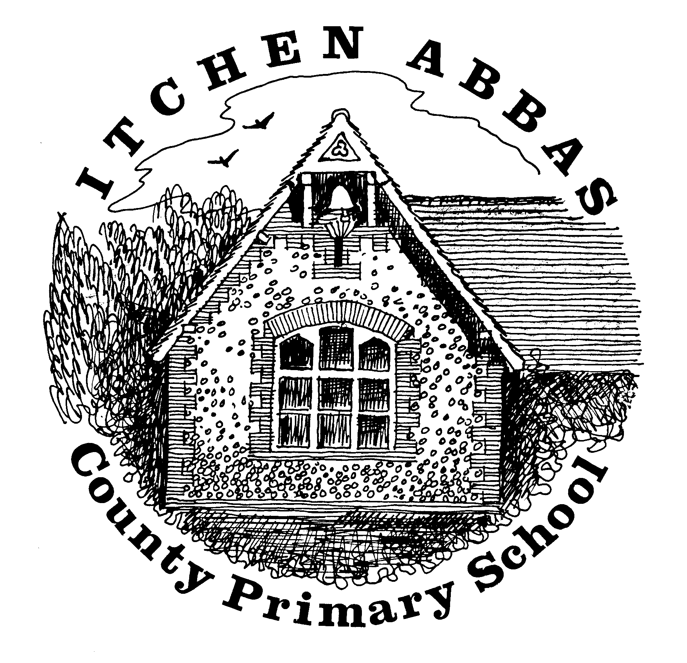
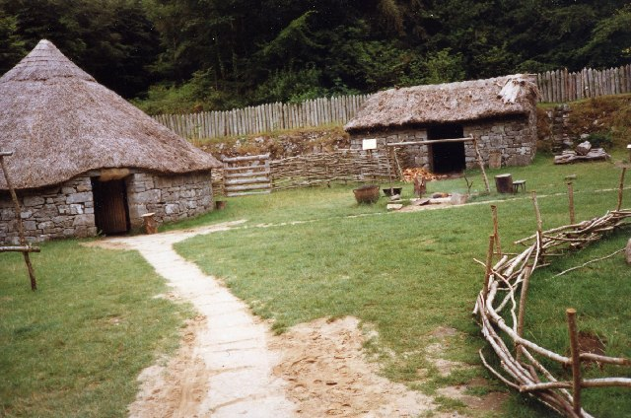
Itchen Abbas Primary School

Hedgehogs overview of Learning for Spring 2 Term 2020

‘What were the main changes from the Stone-Bronze Age? Which do you think had the biggest impact on Britain?’

Overview of Our Topic
This half term we will learn more about the ‘prehistoric’ era by comparing the Stone to the Bronze and Iron Ages. We will conclude our topic at the end of the term by explaining which era we think made the biggest difference and why. Hedgehogs will also be learning and practising songs and lines for their Spring production throughout the half term.
Vocabulary. These are words that we will be using in our learning. To help the children learn these new words, please have some fun using the words at home in different contexts.
Hillforts, armour, Celts, farming, swords, roundhouse, bronze foundry, amber, metal, shields, daggers, tools, weapons, jewellery, axe, hammerstone, antlers, village, wildlife, lifestyle.
English  Hedgehogs will continue to explore a range of texts and write for different purposes. Our world book day will be focused on learning, writing and performing poetry this year. | Science  This half term, Hedgehogs will be learning about materials with Mrs Primmer. They will set up their own experiments and answer enquiry questions through testing and concluding.
Maths  We will continue to strengthen our mental methods when calculating as well as continuing to learn about fractions at the beginning of the half term. | Music  We will be learning songs for our play ‘The Litter Muncher’. We will focus on our tone and pitch when practising these songs daily as well as keeping in time with the music.
History  As we continue our history topic we will be learning about the Bronze and Iron Ages and we will compare these to the Stone Age. We will also discuss the impact this had on our country. | Art  Towards the end of the term, Hedgehogs will explore an artist ‘Jeannie Baker’ and designer ‘William Morris’ we will create a mixed media collage as well as strengthen our drawing skills.
Computing  On Thursdays, Hedgehogs will be applying their writing skills to ICT. Year 2s will create a flipbook and Year 3s will produce and present a Key Note presentation at the end of the term. | PE  For outdoor sessions, Hedgehogs will develop their throwing and catching skills when learning how to play cricket. Our indoor lessons will improve our stretching and balancing skills through yoga.
PSHE  Our theme for this half term is ‘Growing and Changing’ and we will learn the names of our body parts and Year 3s will start to learn about changes to our body as we get older. | RE  The concept this half term is ‘Belief’ and Hedgehogs will be learning how Christians celebrate and tell the Easter Story.


