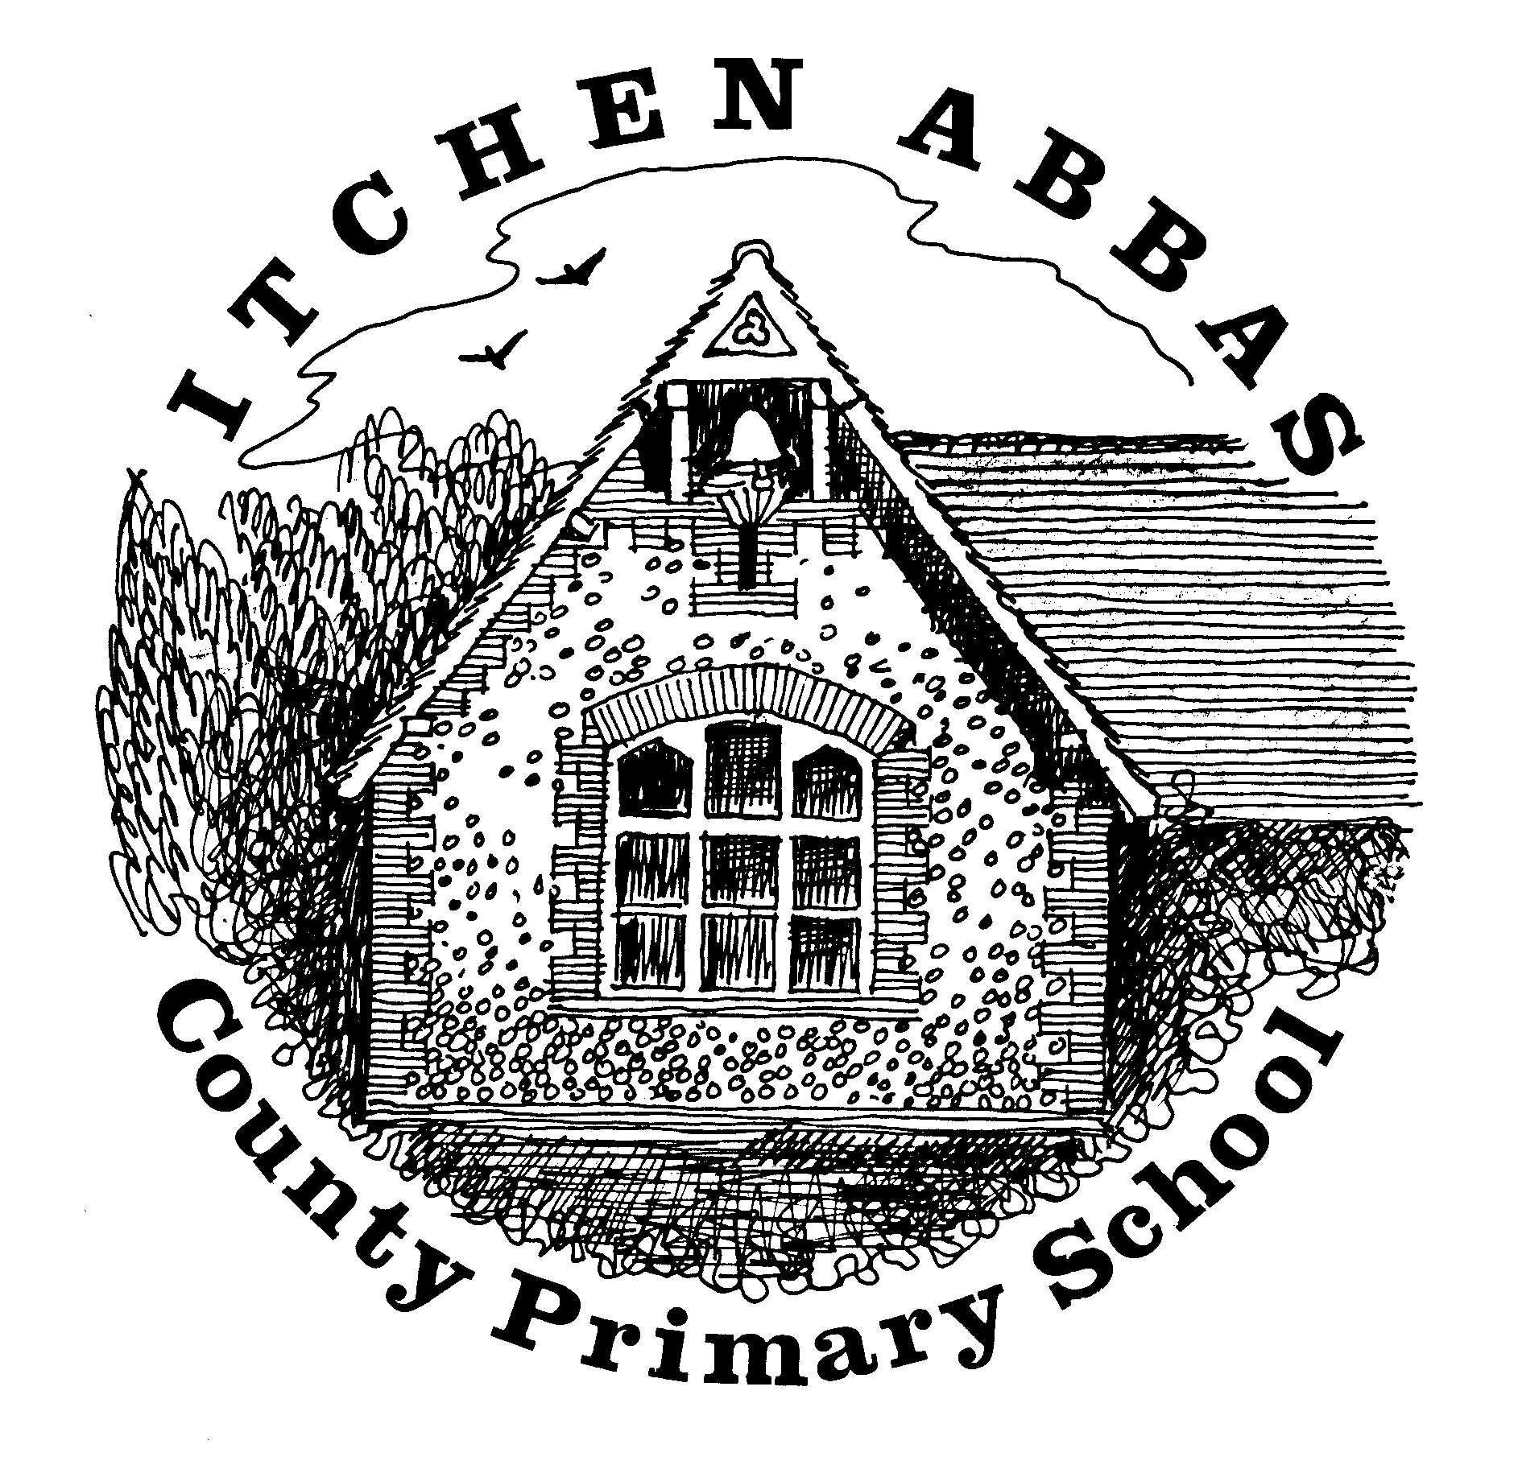
Itchen Abbas Primary School
Homework for Spring 1 2020

Year 3

All children are expected to complete the coloured squares, this is your core homework. White squares are your home learning. Choose at least two of these to complete. Date the squares as you complete them. All homework is to be brought into school each Monday and all homework is due to be completed by Monday 10th February.

Reading Task | Writing Task | Maths Fluency Task | Maths Problem Solving Task
This half term, read two fictional books and explain how their themes are similar/ different.  Due in by Monday 3rd February | Type up a newspaper report about an event that happened in a book that you have recently read or about a fun weekend that you have had.  Due in by Monday 20th January | Times table/ Number bond focus:  Practise counting forwards and backwards in 4s and 8s.  What pattern can you spot?  Practise telling the time to the nearest minute.  Weekly evidence please | Complete ‘Guess My Number’ problem solving task.  Due in Monday 13th February
Spelling |  | Reading
Weekly practice from your spelling journey |  | Record your home reading in your homework book
Topic | Research | Food Tech | Home Learning
Design and create a model Stone Age site using modelling material such as plasticine or playdough. | Find out about a historic Stone Age site in the UK and type up some facts about it. | Research and make Stone Age Oatcakes. Bring in photos and the recipe! | Your choice: choose an activity to help you find out more about our topic.
Music | Going places | Art/DT | Computing
Listen to the BBC bitesize clip ‘Playing instruments made of rubbish’ What instruments can you make? Perform this and take a video to share to the class. | Visit Winchester City Museum and record facts about the Stone Age. | Make a Stone Age tool using natural resources. | Type as many pieces of homework as possible to practise your typing skills.
Reading Challenge | Science Challenge | Maths Reasoning Challenge | Writing Challenge
Read two books by the same author and compare their themes. Produce a venn diagram of the similarities and differences between the books.  Due in by Monday 3rd February | Choose two rocks from outside and set up an experiment to test their properties/characteristics.  Due in by Monday 27th January | Solve the onions reasoning question.  Due in Monday 13th February | Write a scene for a play based on your favourite story. Don’t forget stage directions and how the characters should say their lines!  Due in by Monday 20th January

