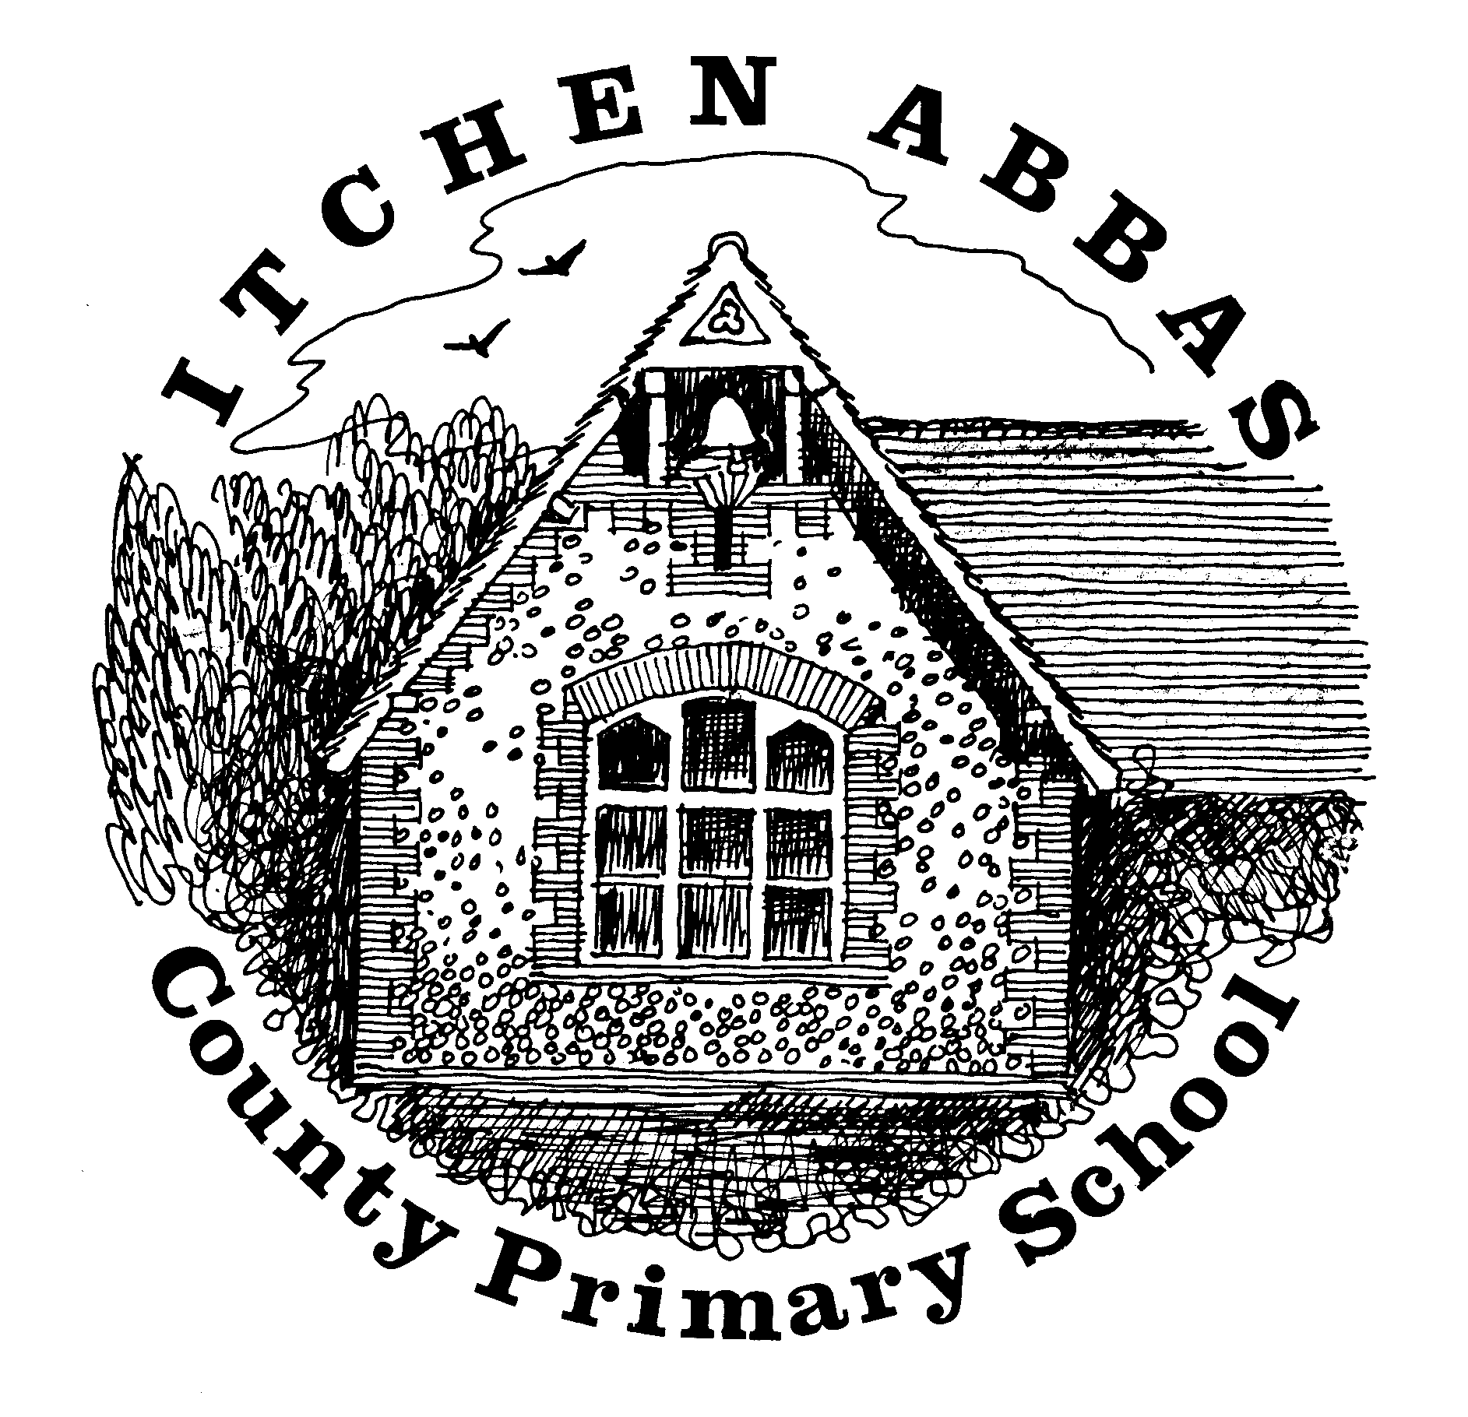
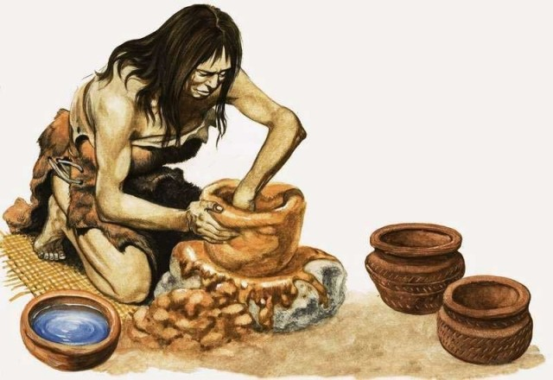
Itchen Abbas Primary School

Class Name overview of Learning for Spring 1 2020

‘How did hunter gathers survive in the Stone Age?’

Overview of Our Topic
This half term our topic will be based on the Stone Age era. We will be exploring what life was like during this time by examining sources, researching famous sites and experimenting with natural resources. We will be answering enquiry questions and explore texts related to the Stone Age.
Vocabulary. These are words that we will be using in our learning. To help the children learn these new words, please have some fun using the words at home in different contexts.
Hunter-gatherer, Palaeolithic, Mesolithic, Neolithic, axe, spear, tools, weapons, mammoth, jewellery, hand-axe, hammerstone, antlers, cave paintings, flint, wildlife.
English  This half term Hedgehogs will be writing a sequel to a story about a Stone Age character. We will also be writing for a range of purposes including to instruct and entertain. | Science  In science lessons with Mr Zilli, Hedgehogs will be exploring properties of rocks and classifying them. They will work scientifically through participating in many experiments.
Maths  We will be focusing on finding fractions of numbers, amounts and shapes as well as comparing 2D and 3D shapes and collecting data. | Music  Hedgehogs will be improving their rhythm and pitch by singing songs about mythical creatures this half term.
History  In topic lessons, Hedgehogs will learn about the first hunters on earth by exploring sources and gathering evidence, constructing timelines and visiting Butser Farm after half term. | Art & DT  Hedgehogs will be discovering what it was like to live in the Stone Age by making cave paintings and cooking stewed fruit then eating it as a Stone Age person would!
Computing  Both year groups will be exploring and developing their coding skills by moving objects and creating a moving animation. | PE  In PE with Mr Robbins, Hedgehogs will be developing their hockey skills and practising drills.
PSHE  This term Hedgehogs will be exploring the concept of growing and changing. We will discuss having our own body space and how we change as we get older. | RE  In RE lessons we will explore the concept of change and discuss stories of the people that Jesus met.


