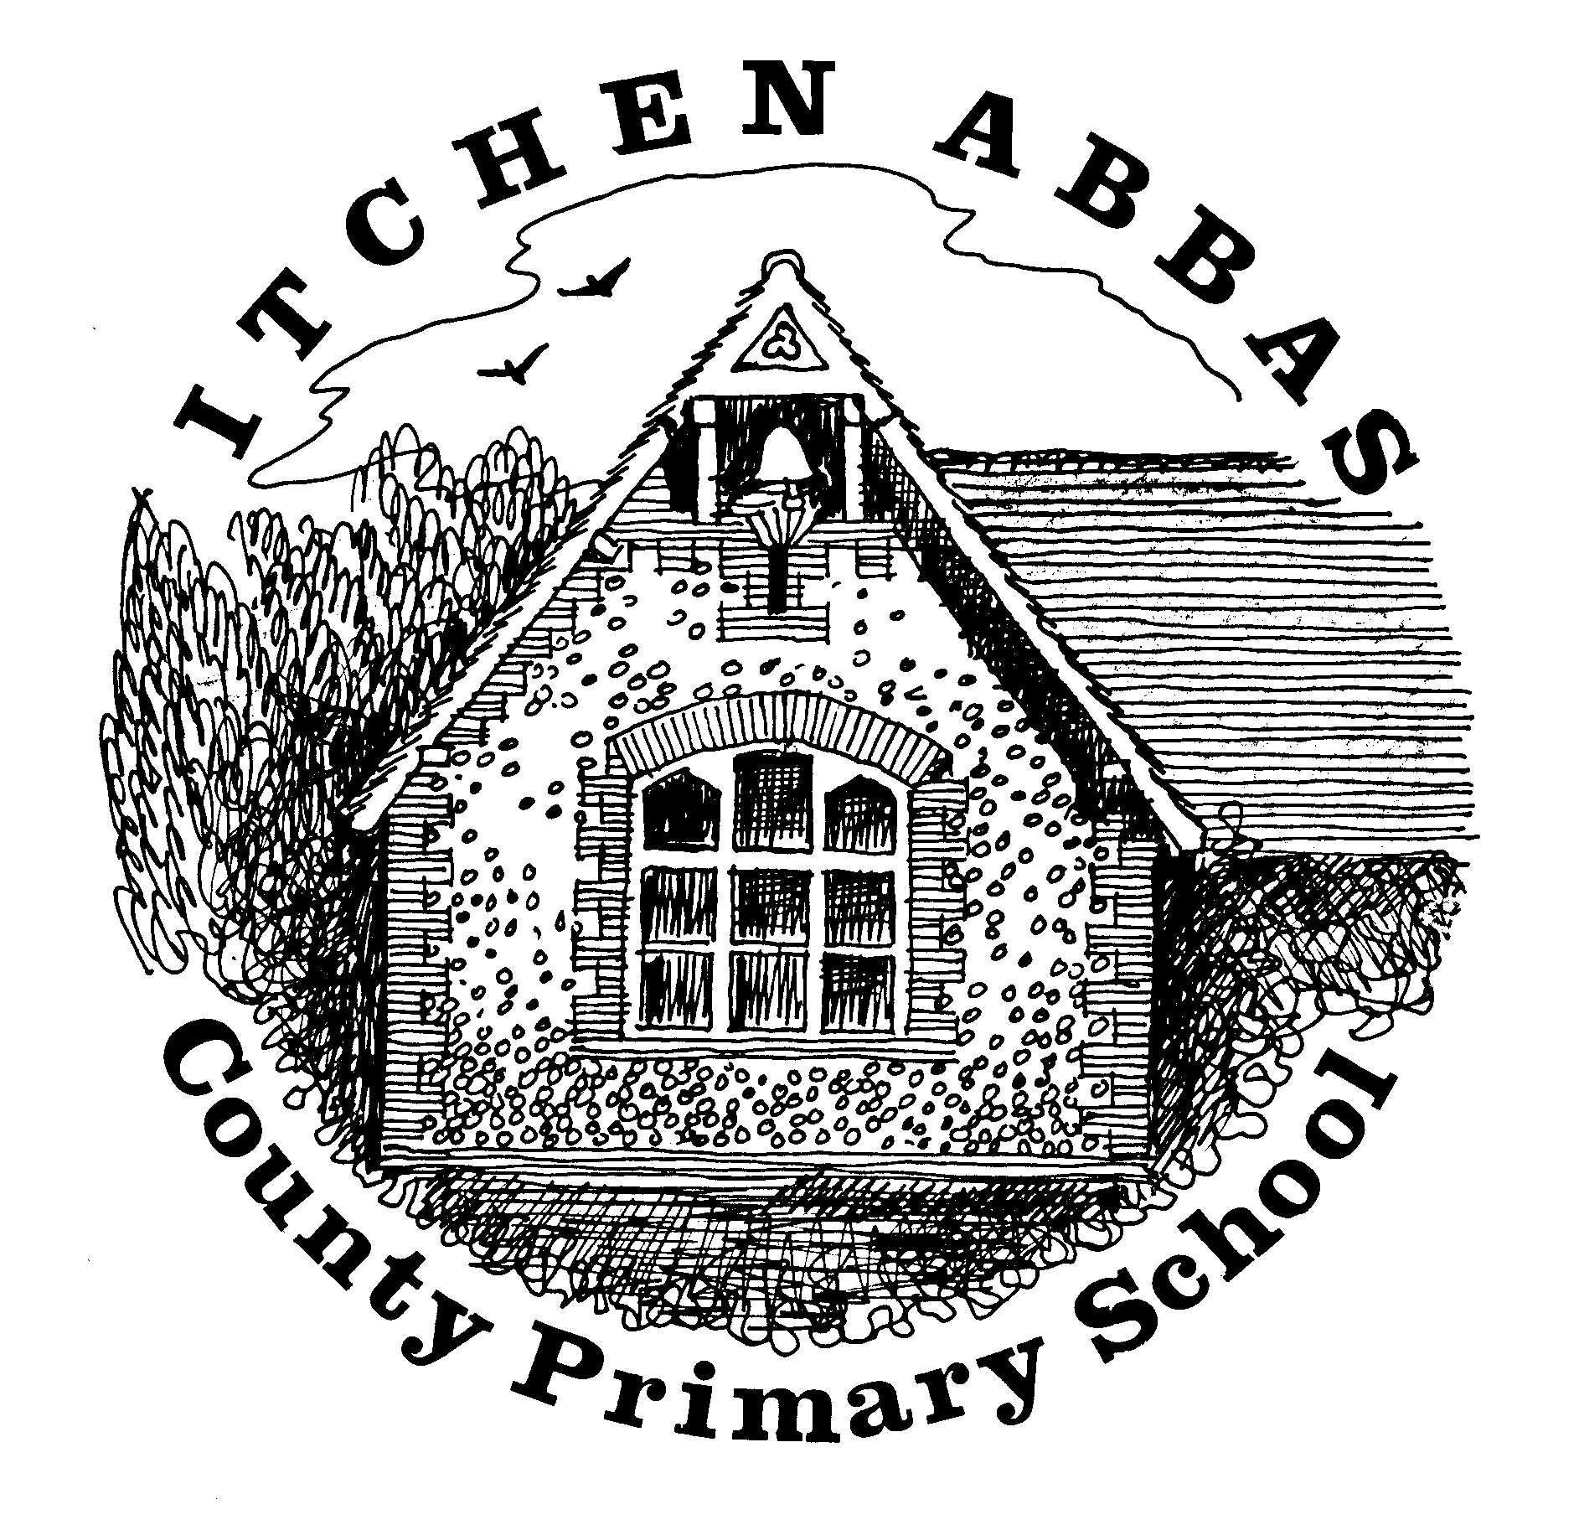
Itchen Abbas Primary School
Homework for Autumn 1 2019/20

Year 1

All children are expected to complete the green squares, this is your core homework. Yellow squares are optional for those of you who want an extra challenge. White squares are your home learning. Choose at least two of these to complete. Date the squares as you complete them.
All topic homework is to be brought into school by 21st October

Reading Task | Writing Task | Maths Fluency Task | Maths Problem Solving Task
This half term read a non-fiction book about an important historical person.  By 20th Sep | Draw a picture of an important person in your life and write down why they are important to you.  By 4th Oct | Counting and times table focus:  Count forwards and backwards up to and beyond 20.  Practise counting forwards in 2’s.  By 27th Sep | Complete the 100 square jigsaw.  By 11th Oct
Spelling |  | Reading
Weekly practice from your spelling journey |  | Record your home reading in your reading record
Topic | Research | Food Tech |  | Home Learning
Explore and research other historical doctors and nurses, like Florence Nightingale, to discover how their work helps us today. | Following on from your reading task, create a fact file about the important person you have researched. | Use some autumnal fruits to create a pudding or sweet treat. |  | Your choice: choose an activity to help you find out more about our topic –
Music | Going places | Art/DT |  | Computing
Practise one of the nursery rhymes with the Makaton signs you have learnt at school. Take a picture and stick it in your homework book. | Go on a tree hunt walk. Take pictures of as many different trees as possible and then label them in your book. | Sketch a portrait of an important member of your family. Remember, this could even be a pet. |  | Draw a map of your house and write down or draw the different pieces of technology in each room.
Reading Challenge | Science Challenge | Maths Reasoning Challenge |  | Writing Challenge
Read a picture book and write a book review about it.  What did you like/ dislike about it?  Who would you recommend it to and why?  By 20th Sep | Create a human digestive system. Follow the instructions on the school internet link on the Squirrel’s class page.  By 27th Sep | Ben has no more than 20 sweets in a bag.  He counts his sweets into groups of 2. He has 1 left over.  Then he counts his sweets into groups of 5. He has 2 left over.  How many sweets could Ben have? Is there more than one answer? Use actual sweets to help you share them out.  By 11th Oct |  | Send an email, letter or postcard to a member of your family explaining what you did in your Summer holidays.  By 4th Oct.

