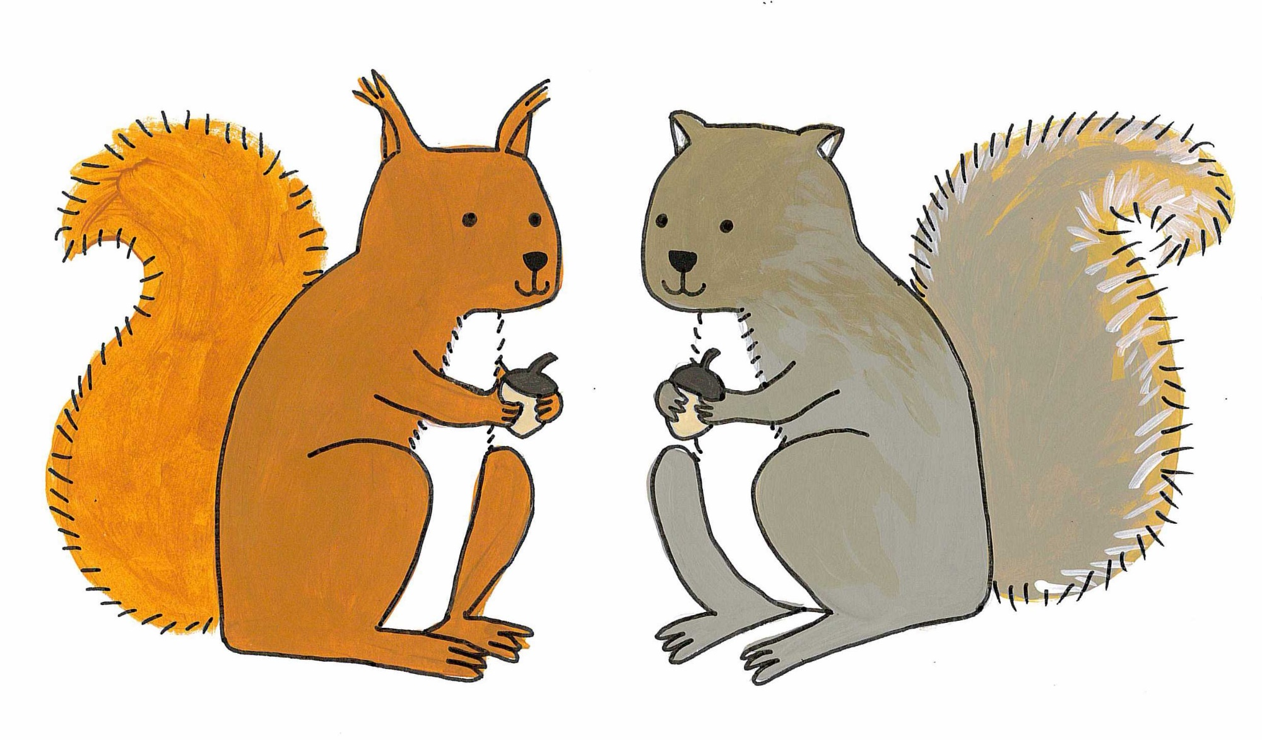
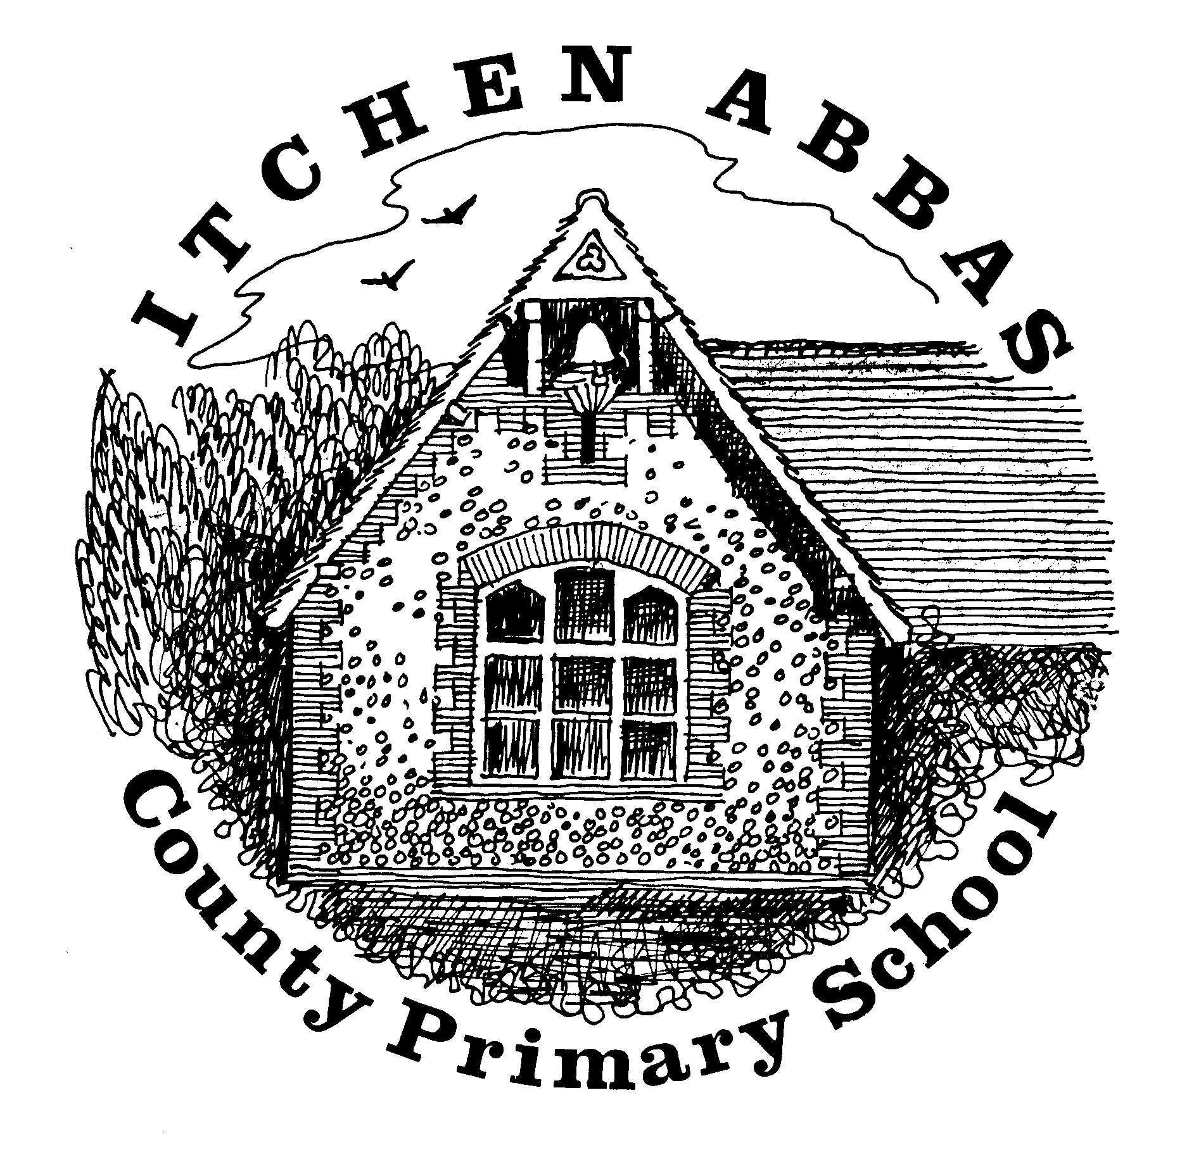
Itchen Abbas Primary School

Squirrel’s overview of Learning for Term 2019/20 Autumn 1

Overview of Our Topic – Who are the important people in my life?
For this topic, the Squirrels will be thinking about the variety of people in society who help us in everyday life. The children will receive many visits from a range of professions and participate in activities to explore why each person’s job is important.
Vocabulary. These are words that we will be using in our learning. To help the children learn these new words, please have some fun using the words at home in different contexts.

profession important essential emergencies special
society medicine investigation comparisons differences

English  Story writing can be a tricky thing, but not for Elliot. He can make stories out of anything. The children will follow Elliot on his journey and practise using Elliot’s skills to create stories of their own. The year R children will have a focus on phonics, letter formation and simple word writing and the year one children will be refining their sentence writing skills. | Science  As our topic focuses on those who help and care for us, the Squirrels will also be learning about how to care for themselves. They will learn about different parts of the human body, how they work and what they need to do to ensure that they stay healthy.
Maths  Numbers are used in everyday situations and this half term, the Squirrels will be exploring numbers within the environment. Before you can calculate with numbers, you need to know what numbers are, therefore, the children will be learning about number and place value. | Music  Mrs Primmer will be teaching the children some well known nursery rhymes, but with a twist. To enhance their language skills, the children will learn Makaton signs to accompany the songs.
History  Whilst the children will be thinking about important people who help us today, they will also be learning about significant figures such as Florence Nightingale. The children will explore and compare how the work she did has influenced our lives today. | Art & DT  In Art, the Squirrels will be learning and applying skills including sketching, printing and painting to create a variety of self-portraits.  Whilst considering how to care for our bodies, the children will be using autumnal fruits to make healthy smoothies in D.T lessons.
Computing  Mrs Primmer will be teaching the children some basic computer skills. The Squirrels will learn how to use a track pad, open applications and type using a keyboard. | PE  Mr Robbins will be helping the children to practise and refine their fundamental P.E skills such as throwing, catching, jumping and running.
PSHE  This year our school values focus around being compassionate to others and ourselves. This half term, the children will be considering how to care for themselves and others with a particular focus on emotions and friendships. | RE  The children will be learning about Harvest festival. They will learn songs and understanding the meaning of the celebration all in preparation for our school’s harvest festival celebration at the church.
