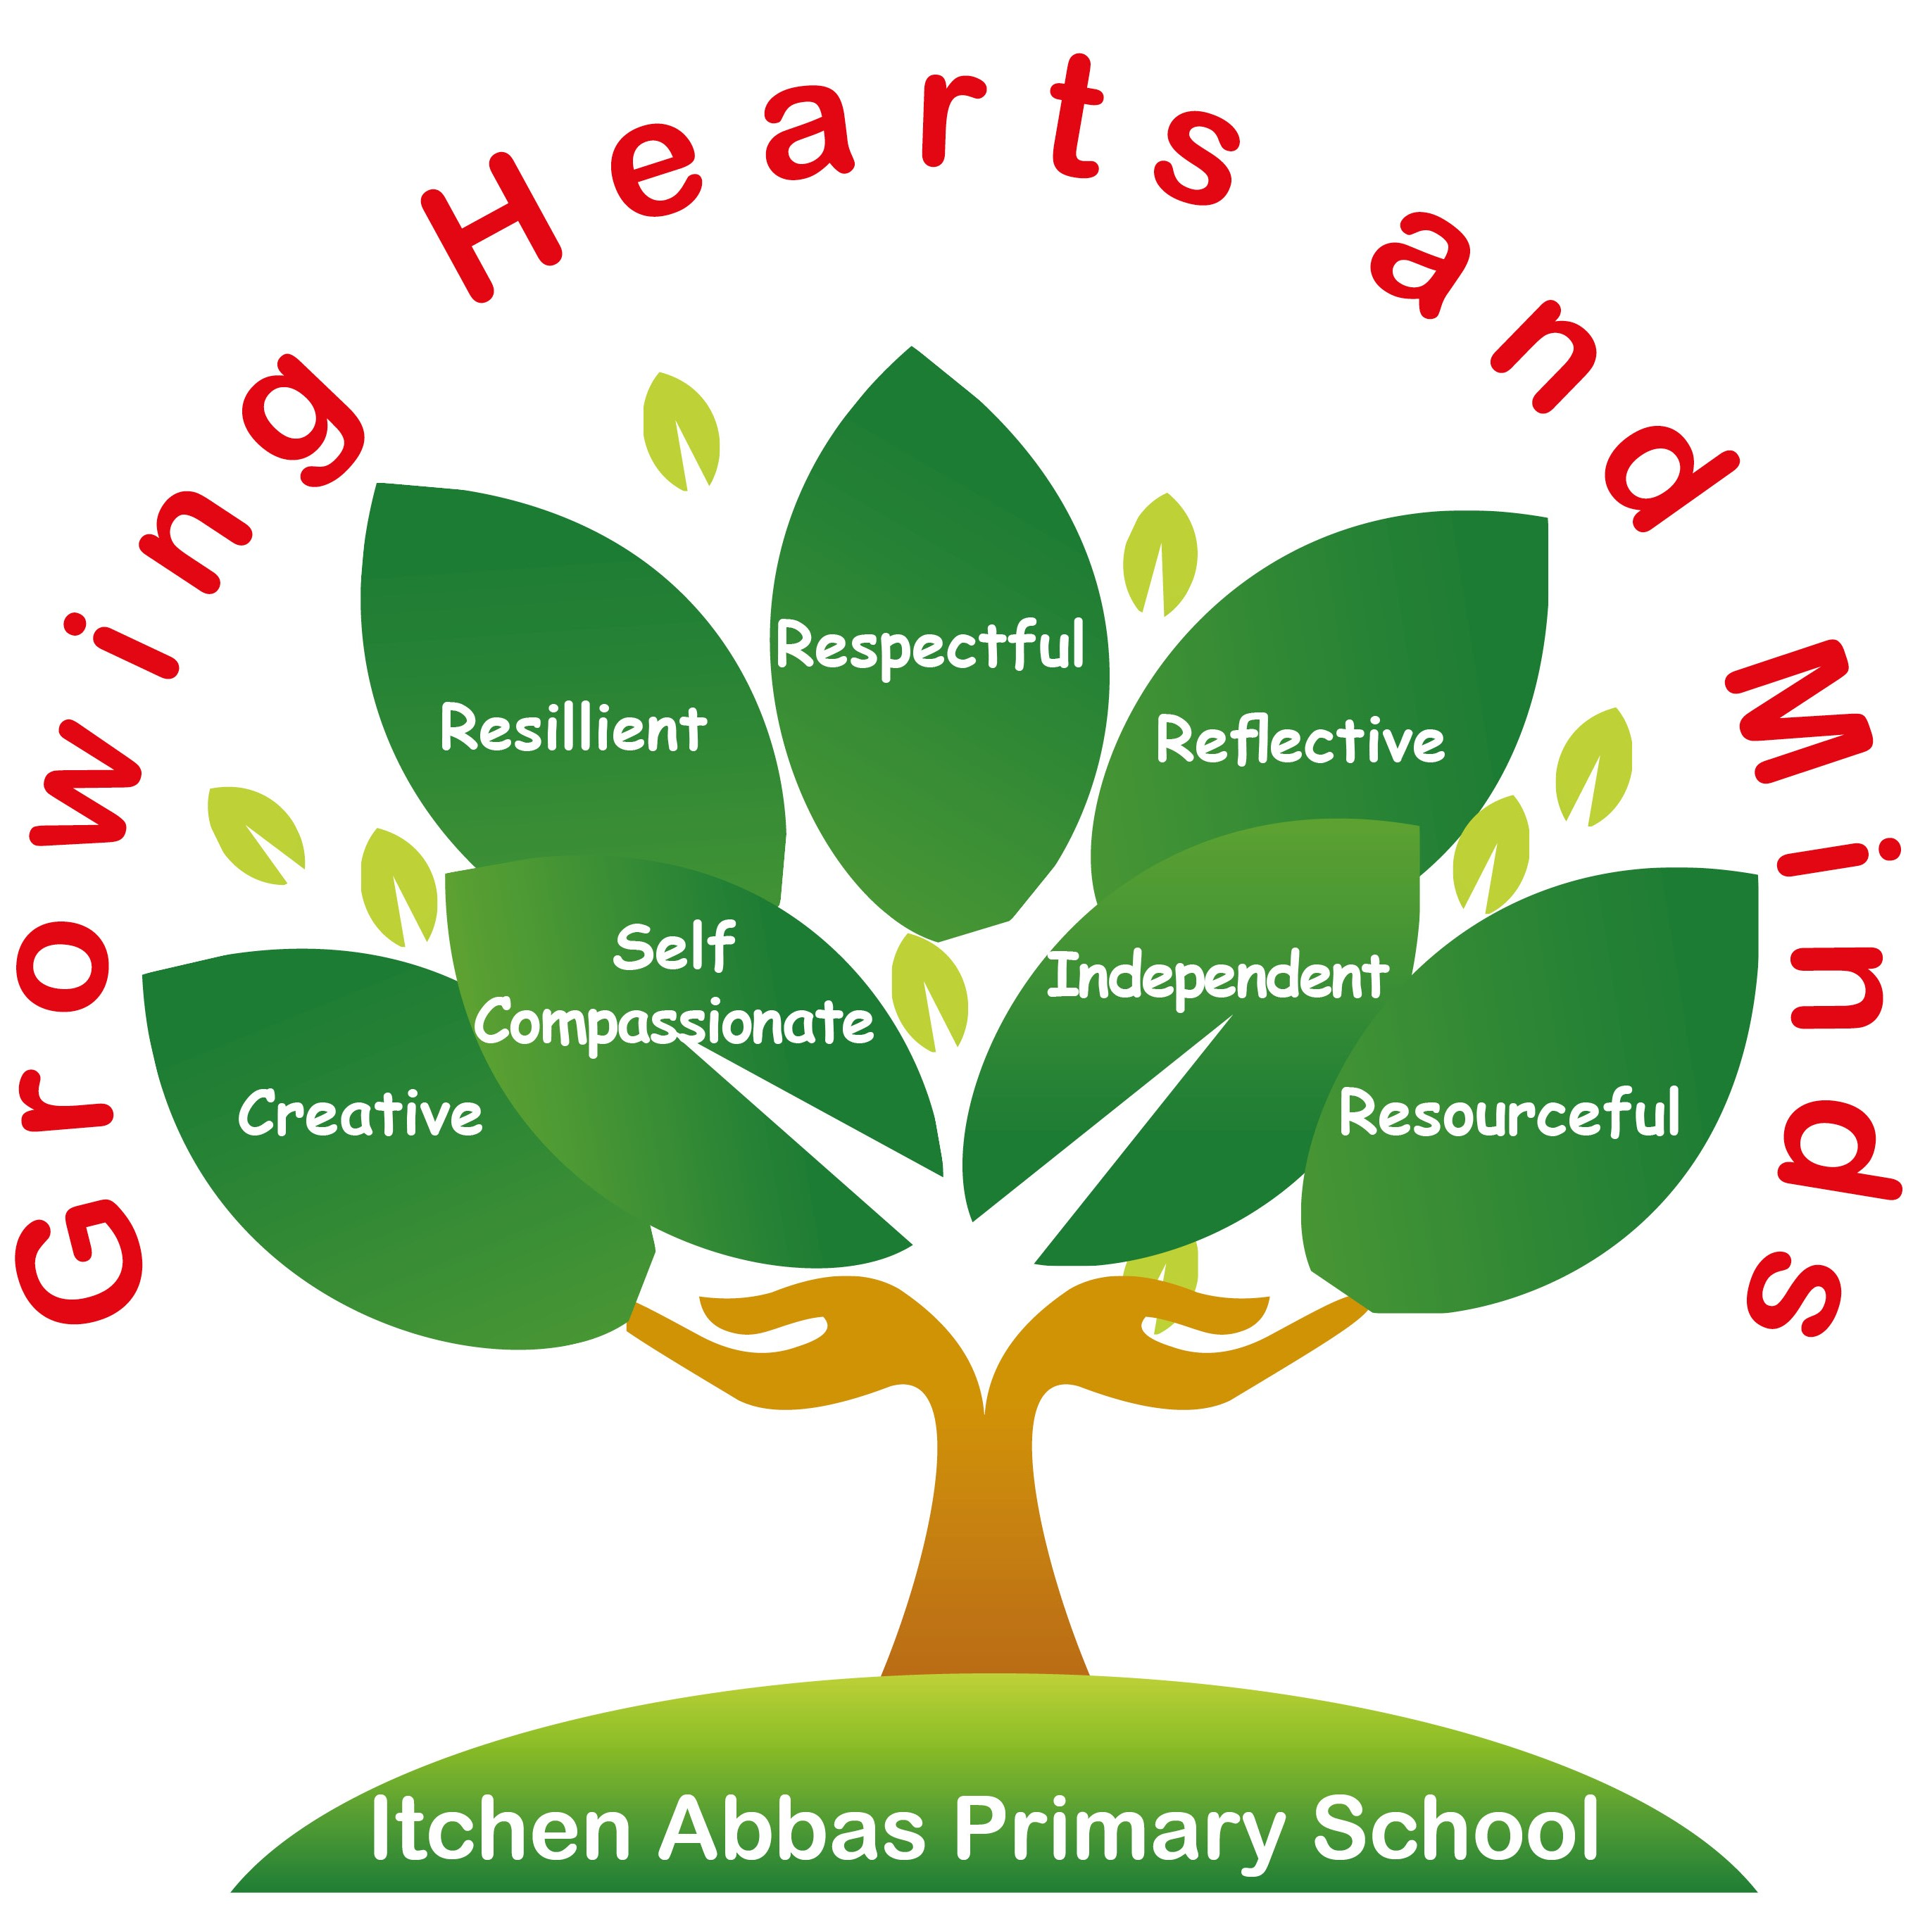
Itchen Abbas Primary School
‘Growing Hearts and Minds’

Subject Development and Rationale

Maths

Intent of our Maths Curriculum

Itchen Abbas is a rural village on the River Itchen about 4 miles north of Winchester. According to the 2011 census, Itchen Abbas has a higher education level than the average for England. The percentage of adults in higher paid, managerial and professional jobs is above average and this manifests into high expectations and ambition for children from their parents. Levels of deprivation are low in the area.

Modern technology has influenced how parents use maths in everyday life therefore, we are noticing that more children are finding aspects of the curriculum difficult as they may not see these skills applied at home. Examples of these include using electronic devices to calculate instead of using mental methods or using credit or debit cards to pay for items rather than using coins and working out change. We ensure that enough time is dedicated to teach these objectives so that all children have the ability to apply these skills in the wider world and are prepared for future employment.

At Itchen Abbas, we understand that maths is an essential aspect of everyday life that provides an understanding of the world. Children are taught maths using a mastery-based approach that encourages learning concepts in sequences so that children deepen their knowledge and have a relational understanding of the subject.

Therefore, our maths curriculum aims to:

- Allow all pupils to access the curriculum, with the appropriate challenge and support, in order to become fluent, reason and problem solve.
- Prepare children for everyday experiences by mastering concepts in a variety of ways.
- Show engagement and confidence in lessons, therefore building an enjoyment of the subject throughout the school.

In Key Stage One, the focus of maths teaching is to ensure that children develop confidence and mental fluency with numbers, counting and place value. They will learn important number facts that will support calculations and begin to record multiplication tables that will be developed in Key Stage Two. Children start to build connections between areas of the curriculum such as multiplication and fractions.

In Years 3 and 4, our maths teaching focuses on ensuring that children have secured number facts, are confident with calculating using the four operations and develop efficient written and mental methods to calculate with increasingly large whole numbers. They continue to make connections between mathematical domains and can speak about this more confidently.

In Years 5 and 6, the focus of our maths teaching is enabling children to extend their understanding of the number and place value system as well as be able to select appropriate written or mental methods when calculating. There are able to make further connections between areas of the curriculum and apply these confidently in a range of subjects.

Implementation of our Maths Curriculum

The implementation of maths is supported by:

Scheme of Work

- Our school follows White Rose Curriculum scheme to inform our maths planning. The coherent plans and resources are adapted to suit the needs of all learners in the classroom and to suit each year groups’ current circumstances relating to end of year data and assessments.
- Supporting resources are used alongside this scheme to secure children’s knowledge and enhance the learning, such as the NCETM materials or Dip and Pick cards.
- Each domain is split into small steps so that children are given appropriate time to master concepts and deepen their understanding.
- Conceptual and procedural variation are used throughout each learning journey to ensure children can show a concept using different representations and become efficient mathematicians.
- Each domain outlines key questions, misconceptions, stem sentences and possible curriculum links to explore.
- The scheme relates to the ready-to-progress criteria and plans are adapted to meet the needs of the KS1 and KS2 interim framework 2018/2019 onwards.

The subject leader engages in regular discussions with staff relating to the scheme of work and children’s progress and updates the long-term plan if appropriate.

Organisation and Sequence of Learning

- Children are taught in groups daily, following our pupil led teaching school approach, and encouraged to complete independent tasks relating to fluency, reasoning and problem solving in each lesson.
- In a typical lesson, small steps are followed to ensure concepts are being stored in our children’s long-term memory. Adults model representations and strategies, flexible groupings are used and children engage in mathematical discussion.
- The school follows a Concrete, Pictorial, Abstract approach (CPA) to enable children to build competency and develop a clear understanding of a concept.
- The domains of the curriculum are revisited throughout the year by using retrieval tasks such as White Rose flashback cards as well as answering reasoning questions and solving problems that relate to multiple areas of the maths curriculum.
- Teachers plan and adapt lessons using their own professional judgement and complete daily formative assessments. Feedback is provided to pupils through live marking which informs teaching for the next lesson.
- End of domains and term tests are completed to inform planning and assessments.

Vocabulary and Abstract Terms

At Itchen Abbas, we expect children to clearly articulate their ideas and reasoning processes, enabling deeper learning. We expect children to make some mistakes, analyse them and learn from them, justifying and explaining as they do this.

The quality and variety of language that pupils hear and speak are key factors in developing their mathematical vocabulary and presenting a justification or argument. Vocabulary is explicitly taught through a learning journey using stem sentences and representations for support. Language is displayed on the working wall and may be found in books or on tables. The definition and application of vocabulary is continuously modelled and there is an expectation for children to use this in their verbal and written reasoning.

Enrichment

- Children have access to a range of quality resources to enhance their learning such as Dip and Pick cards, the I see reasoning document and problem-solving cards. We also have a range of practical resources in the school for every class such as numicon and dienes blocks.
- Teachers sometimes plan outdoor learning sessions for the children and use the engaging, practical tasks document has been developed from Year R to Year 3 to support teachers’ planning. The school grounds also enhance children’s learning as our playground offers many opportunities to practise maths.
- When possible, extra maths sessions for greater depth learners are offered from other schools and colleges such as Winchester college and Henry Beaufort.
- Children are given opportunities to apply practical skills in engaging ways such as cooking, designing and making products and investigation tasks.
- Children are given opportunities to practise, stretch, investigate and apply their maths skills through weekly PLT and morning tasks in years 1 – 6.

Support for Staff and Subject Knowledge Development

- In our small school, it is not always possible to have an expert in each subject within the staff. Therefore, we use the National College as well as Hampshire to support subject leaders to develop their own expertise. We also have good ties with our feeder secondary school, Henry Beaufort, and local primaries and have developed networks to support our curriculum development.
- The subject leader regularly coaches staff and offers support with planning, assessment and delivers CPD in staff meetings across the year.
- Relevant resources to support teachers’ subject knowledge, planning and assessment are located on the schools’ server.
- The school has a current subscription to the White Rose premium resources for all staff which offers schemes of work, teaching videos, courses and mastery resources.

How this Subject Works Alongside Others

- Where possible, cross curricular links are made in topics with maths. Examples of this include art work that focuses on the use of shapes and lines, measuring and calculating the cost of ingredients in DT lessons and analysing graphs in science lessons.
- We aim to develop children’s reasoning and problem-solving skills across the curriculum by planning opportunities for discussions that encourage them to explain their thinking which helps to develop their ability to reason in maths.

Early Years

In Early Years, maths is predominately taught through separate lessons influenced by the White Rose scheme of learning and implemented throughout provision. These focussed, mastery-based teaching sessions ensure that children learn new concepts that can be demonstrated in their independent learning. The Early Years Leader follows the long-term overview for their class and will use appropriate scaffolds and resources to support these plans. We anticipate seeing maths in Early Years through the following areas and specific goals:

Communication and Language | - Listen attentively and respond to what they hear with relevant questions, comments and actions when being read to and during whole class discussions and small group interactions;  - Make comments about what they have heard and ask questions to clarify their understanding;  - Hold conversation when engaged in back-and-forth exchanges with their teacher and peers.  - Participate in small group, class and one-to-one discussions, offering their own ideas, using recently introduced vocabulary;  - Offer explanations for why things might happen, making use of recently introduced vocabulary from stories, non-fiction, rhymes and poems when appropriate;  - Express their ideas and feelings about their experiences using full sentences, including use of past, present, and future tenses and making use of conjunctions, with modelling and support from their teacher.
Personal, Social and Emotional Development | - Set and work towards simple goals, being able to wait for what they want and control their immediate impulses when appropriate;  - Give focused attention to what the teacher says, responding appropriately even when engaged in activity, and show an ability to follow instructions involving several ideas or actions.  - Be confident to try new activities and show independence, resilience and perseverance in the face of challenge.
Mathematics | Number  - Have a deep understanding of number to 10, including the composition of each number;  - Subitise (recognise quantities without counting) up to 5;  - Automatically recall (without reference to rhymes, counting or other aids)  number bonds up to 5 (including subtraction facts) and some number bonds to 10, including double facts.  Numerical Patterns  - Verbally count beyond 20, recognising the pattern of the counting system;  - Compare quantities up to 10 in different contexts, recognising when one quantity is greater than, less than or the same as the other quantity;  - Explore and represent patterns within numbers up to 10, including evens and odds, double facts and how quantities can be distributed equally.

Impact of our Curriculum

Assessment and Progression

- Staff complete formative assessments regularly through discussions, marking and observations which helps to inform planning, interventions and the deployment of staff. Some learning journeys may start with a problem to solve which helps to identify children’s prior knowledge before a domain is taught.
- At the end of Key Stage One and Two, children participate in the SATs assessments. Children prepare for this throughout the year with practise questions and results are analysed by teachers and the subject leader to inform medium and long-term plans. Although KS1 SATs are no longer a legal requirement, these are still used in our school to support teacher assessments and prepare them for future summative assessments.
- All classes complete regular summative assessments which informs future planning and interventions.
- Teachers input data throughout the year which is then analysed by the subject leader who offers support for planning in the weaker areas of the curriculum.

Monitoring and Pupil Voice

- Subject leaders evaluate the understanding of maths concepts and vocabulary through pupil voice of different groups of children and abilities. This may be done through observations, lesson drop ins or pupil interviews which supports the subject leaders’ evaluation of the subject.
- Subject leaders regularly scrutinise children’s work in books to evaluate the impact of teaching, advise the teacher on support for planning and identify next steps in CPD.
- During observations and drop ins, leaders monitor how teachers have adjusted their lessons and supported children with additional needs so that all children have appropriate stretch and support. Feedback is given from these observations and teachers are given whole school and individual strengths and areas for development.

