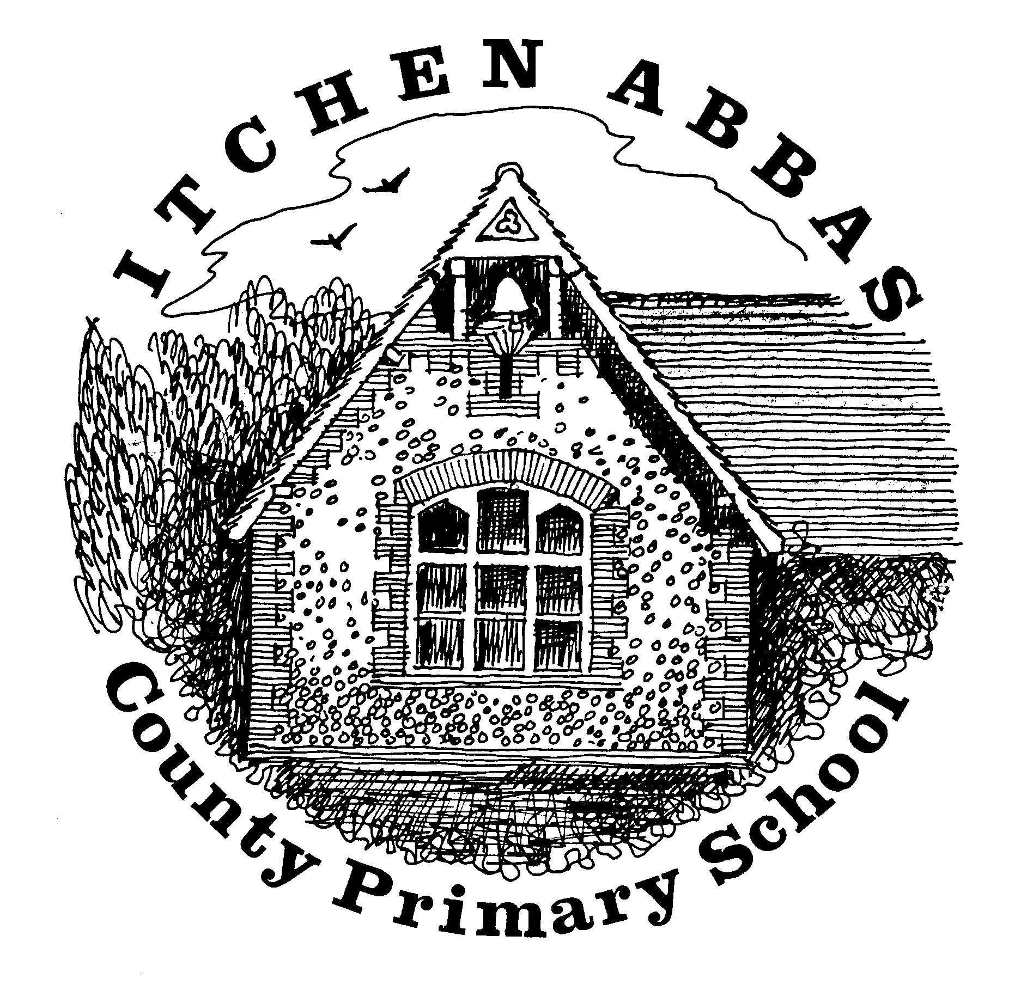
Itchen Abbas Primary School
Homework for Autumn 2 2019/20

Year 3

All children are expected to complete the green squares, this is your core homework. Yellow squares are optional for those of you who want an extra challenge. White squares are your home learning. Choose at least two of these to complete. Date the squares as you complete them. All homework is to be brought into school by

Reading Task | Writing Task | Maths Fluency Task | Maths Problem Solving Task
This half term, read a selection of books and write a blurb for at least two of them. | Write winter poem using prepositions.  Can you include rhyming couplets? | Times table/ Number bond focus:  Count forwards and backwards in 2s, 4s and 8s.  What pattern can you spot?  Choose a number and practise counting in 10s and 100s from that number. | ‘Stickers’ problem.  Break the problem into smaller chunks when solving.
Spelling |  | Reading
Weekly practice from your spelling journey |  | Record your home reading in your homework book
Topic | Research | Food Tech | Home Learning
Create a poster explaining the different types of land settlements (nuclear, dispersed, isolated and linear). | Find out about a Find out about a coastal town and explain why people might want to live there. | Research and cook a tradition Scottish, Welsh or Northern Irish dish. | Your choice: choose an activity to help you find out more about our topic.
Music | Going places | Art/DT | Computing
Research an R&B artist from the 1980s or 1990s. Learn one of their songs and think about how R&B has changed over time. | Visit a local village, town or city – how is the land used there? Create an information leaflet on your chosen place – remember to use paragraphs under your subheadings. | Explore the different sculptures in Winchester. Choose your favourite and research the sculptor, write five facts about them. | . Practise your coding skills using Tynker or  create a presentation (using powerpoint or keynote) about the village, town or city you visited.
Reading Challenge | Science Challenge | Maths Reasoning Challenge | Writing Challenge
Read two books by the same author. Compare how their similar/ different. What impact do they have on their reader? What interesting language do they use? Record the ideas in your homework book. | Design and create your own microhabitat for your garden. Record how many bugs your find using a table and graph. | Complete reasoning task ‘Missing digits’ and ‘Mental or written’.  Use the reasoning sentence starters ‘I started by...’ ‘I noticed that...’ | Write a story of your choice but write a new chapter each week. Consider the impact you want on your reader and challenge yourself to use some of the language you recorded for the reading challenge.

