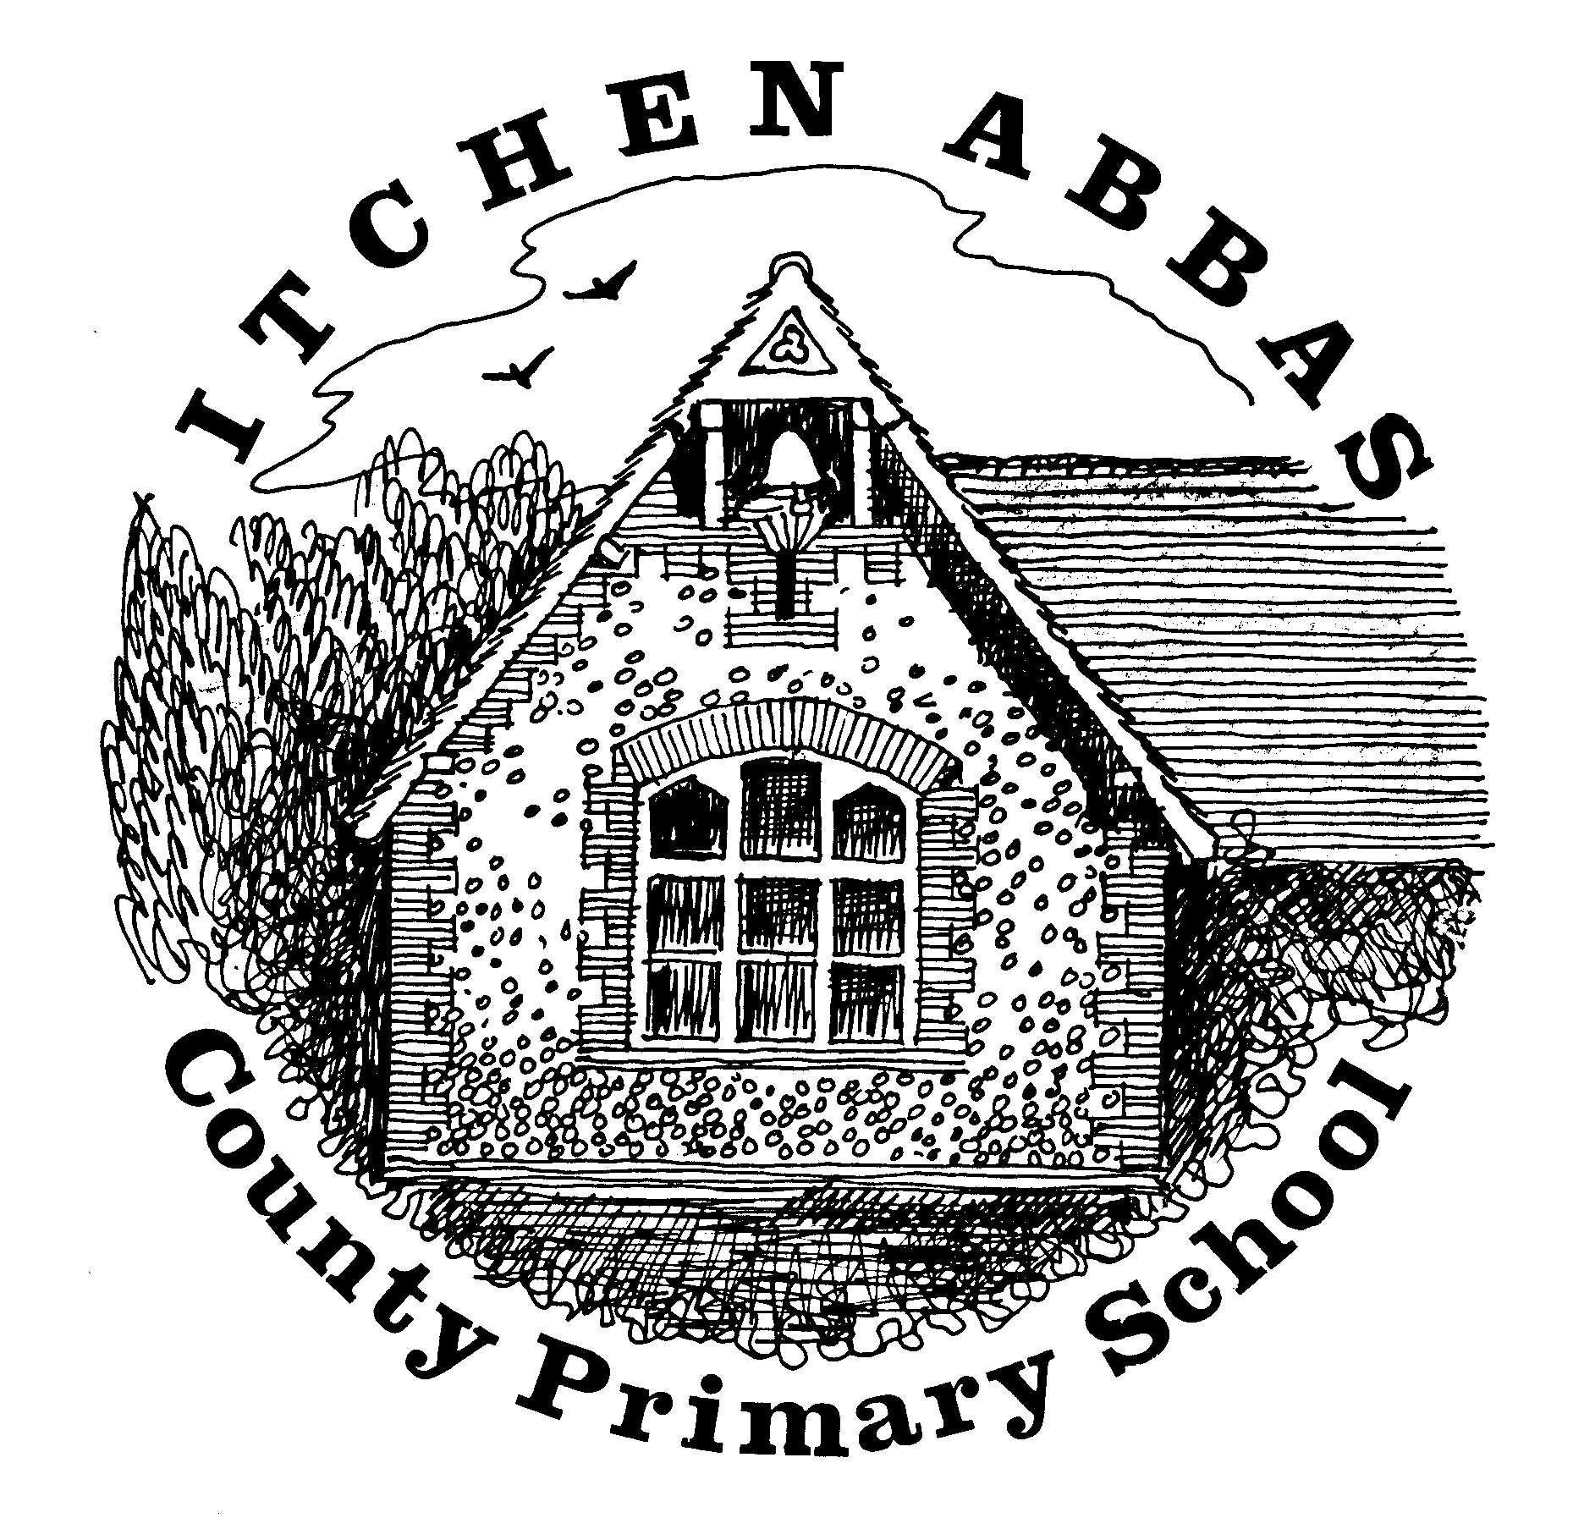
Itchen Abbas Primary School
Homework for Autumn 1 2019/20

Year 3

All children are expected to complete the green squares, this is your core homework. Yellow squares are optional for those of you who want an extra challenge. White squares are your home learning. Choose at least two of these to complete. Date the squares as you complete them. Spelling steps will be stuck in every 2-3 weeks for you to practise your spelling rules at home.
All topic homework is to be brought into school by 21st October

Reading Task | Writing Task | Maths Fluency Task | Maths Problem Solving Task
This half term read a non-fiction book about the UK and at least two fictional books. Write a book review of one of your books.  By 20th Sep | Write a character and setting description from a book that you have read recently.  By 4th Oct | Times table/ Number bond focus:  Count forwards and backwards in 3s and 4s.  Practise your number bonds to 100 then 500.  By 27th Sep | ‘Different Ways’ reasoning question.  By 11th Oct
Spelling |  | Reading
Weekly practice from your spelling journey |  | Record your home reading in your homework book
Topic | Research | Food Tech | Home Learning
Draw a map of your local area surrounding your house. What physical and human features can you include on your map? | Find out about a town/city/village that has different type of land settlement to Itchen Abbas. | Research and cook a famous British dish. Add your own ingredient to give it a twist and write up the recipe. | Your choice: choose an activity to help you find out more about our topic –
Music | Going places | Art/DT | Computing
Research a folk song from the UK and sing the song to family or friends. | Walk around your local area and see what human and physical features you can find. Choose a similar local area and compare the two. | Research a famous artist and create a painting in the same style but using a different media such as pastels or paints. | Practise your coding skills using the website code studio. Create a new picture or moving sprite on the website.
Reading Challenge | Science Challenge | Maths Reasoning Challenge | Writing Challenge
Read a chapter book and write a book review about it. Who would you recommend it to and why? Write a blurb for the book.  By 20th Sep | Design a habitat for a new creature. Justify your design choices, how have they adapted to your habitat?  By 27th Sep | Number Differences Nrich problem.  By 11th Oct | Produce a poster advertising Itchen Abbas to tourists. Persuade them to visit the village, justify the language you choose.  By 4th Oct

