Year 2 fractions
Pet/friends

Olympic Starters

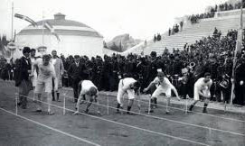
This is the start of the 100 metres in 1896. In that year Thomas Burke from the USA won the race in 12 seconds.
I wonder how far you could run in 12 seconds.
You and your friends could use a stop watch and then measure how far you ran.

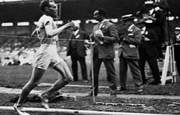
This is the finish of the 200 metres in 1924. Jackson Scholz from USA won that race in just over 21 seconds.
I wonder if you could run the 100 metres in that time?
Or you could see how far you could run in 22 seconds.

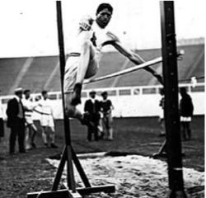
This is the high jump in 1906. It shows Ray Ewry from the United States.
He jumped 1 metre 56 centimetres.
How high can you jump?
See how high 1 metre 56 centimetres is.
Can you find someone who can jump that high?

This is the triple jump, which is a hop, step and jump. In 1906 it was Peter O'Connor from Ireland who won a silver medal. He jumped about 15 metres. What's your best hop, step and jump?
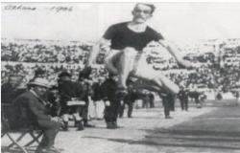

Year 3 fractions question

